STRING, STRING BUFFER AND STRING BUILDER

Once we create a string object, we are not able to perform any changes on that object. If some changes are made, then with those changes a new object will be created. This non changing behaviour is immutability.

In below code, after doing new object using concat method, a new object will be created but since this object does not have any reference, it will be garbage created.

In case of String Buffer, the append method make changes to the same object. So, it is mutable.

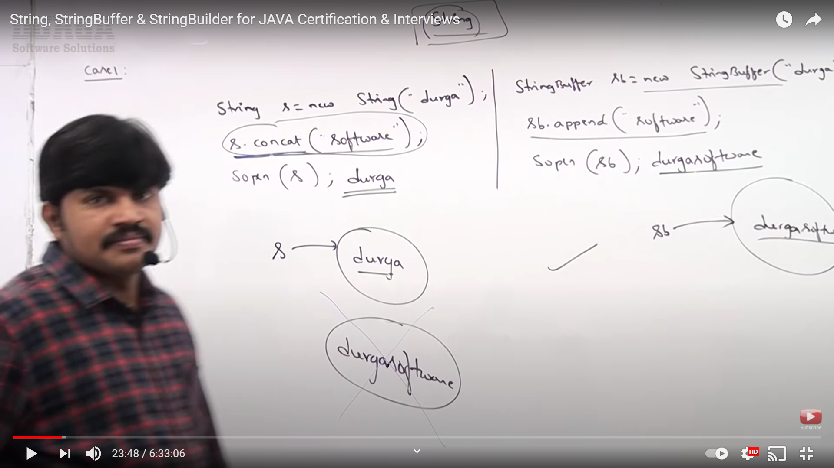

CASE: 2 – **In String Class**, ‘==’ is always meant for reference comparison while equals method is used to check the content in the Object. (We use **‘NM’.equals(variable).** This is used for content comparison and also to avoid NPE if we used **variable.equals(‘NM’) ;)**

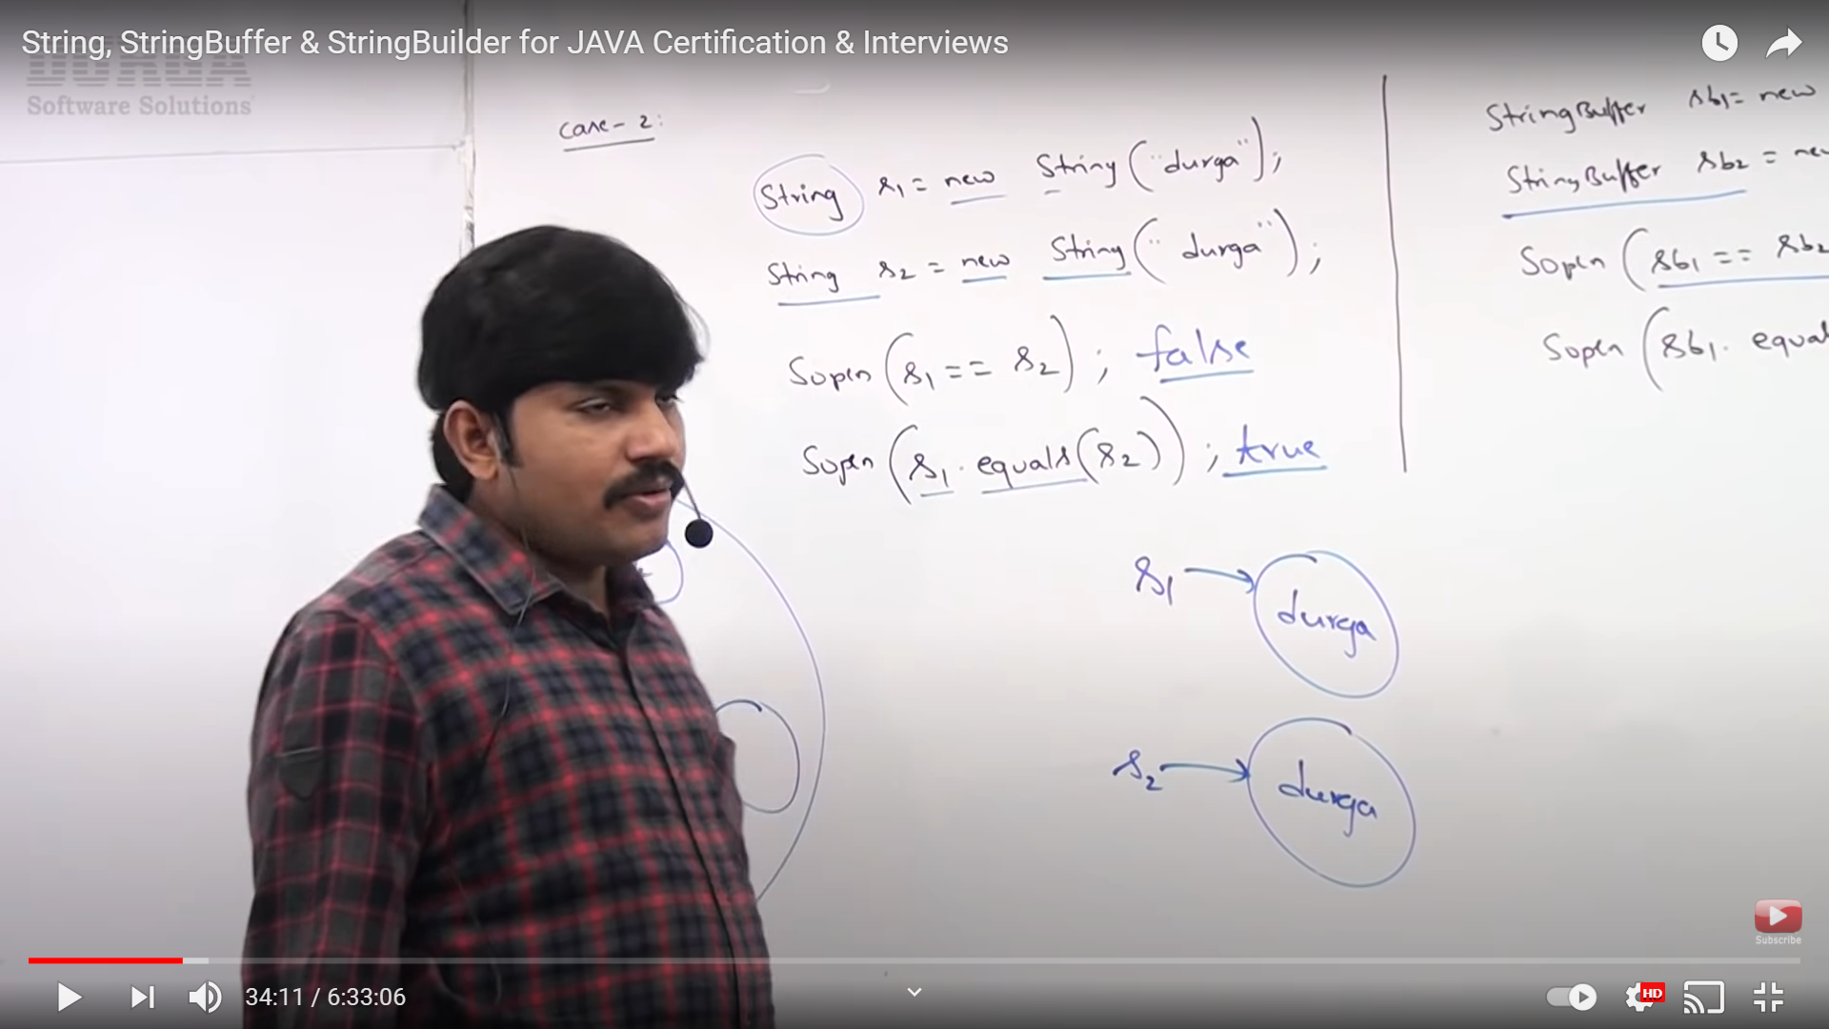

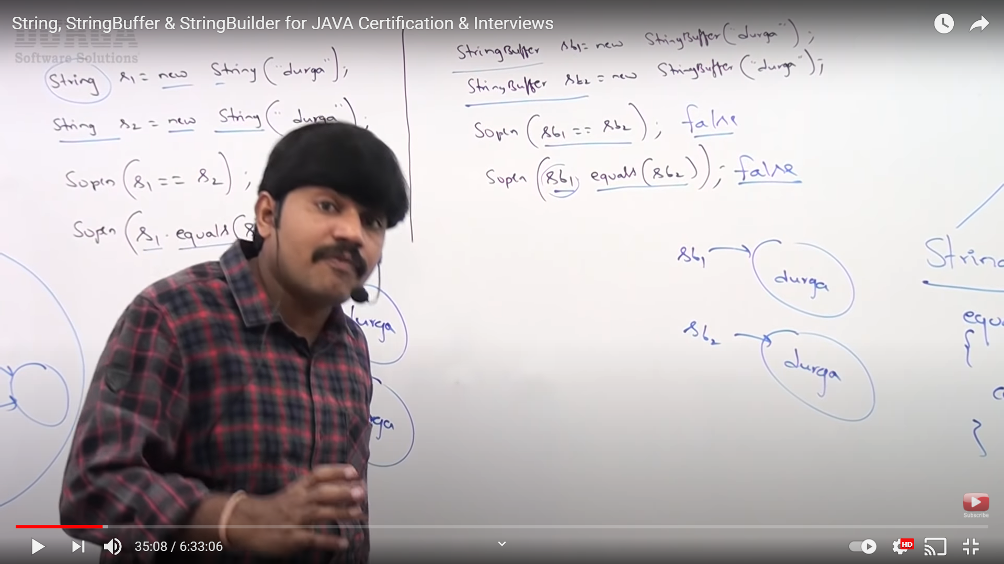

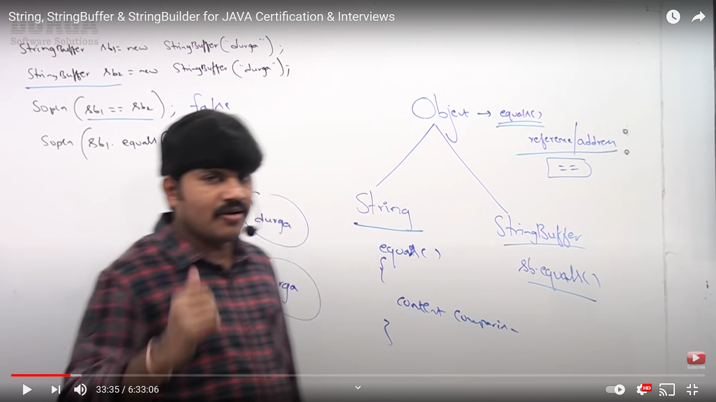

‘==’ everywhere and in all classes do reference comparison but equals methods does not do content comparison in all the classes. Both String and StringBuffer classes are child class of Object class. Object class has total 12 methods ( 1 private and 11 public like equals, hashCode, toString etc.). The object class equals method is meant to do reference comparison. Since, the equals method in overridden in String class to do content comparison, String class equals method do content comparison and StringBuffer equals methods do reference comparison since equals method is not override in StringBuffer. So we need to override equals method to do content comparison.

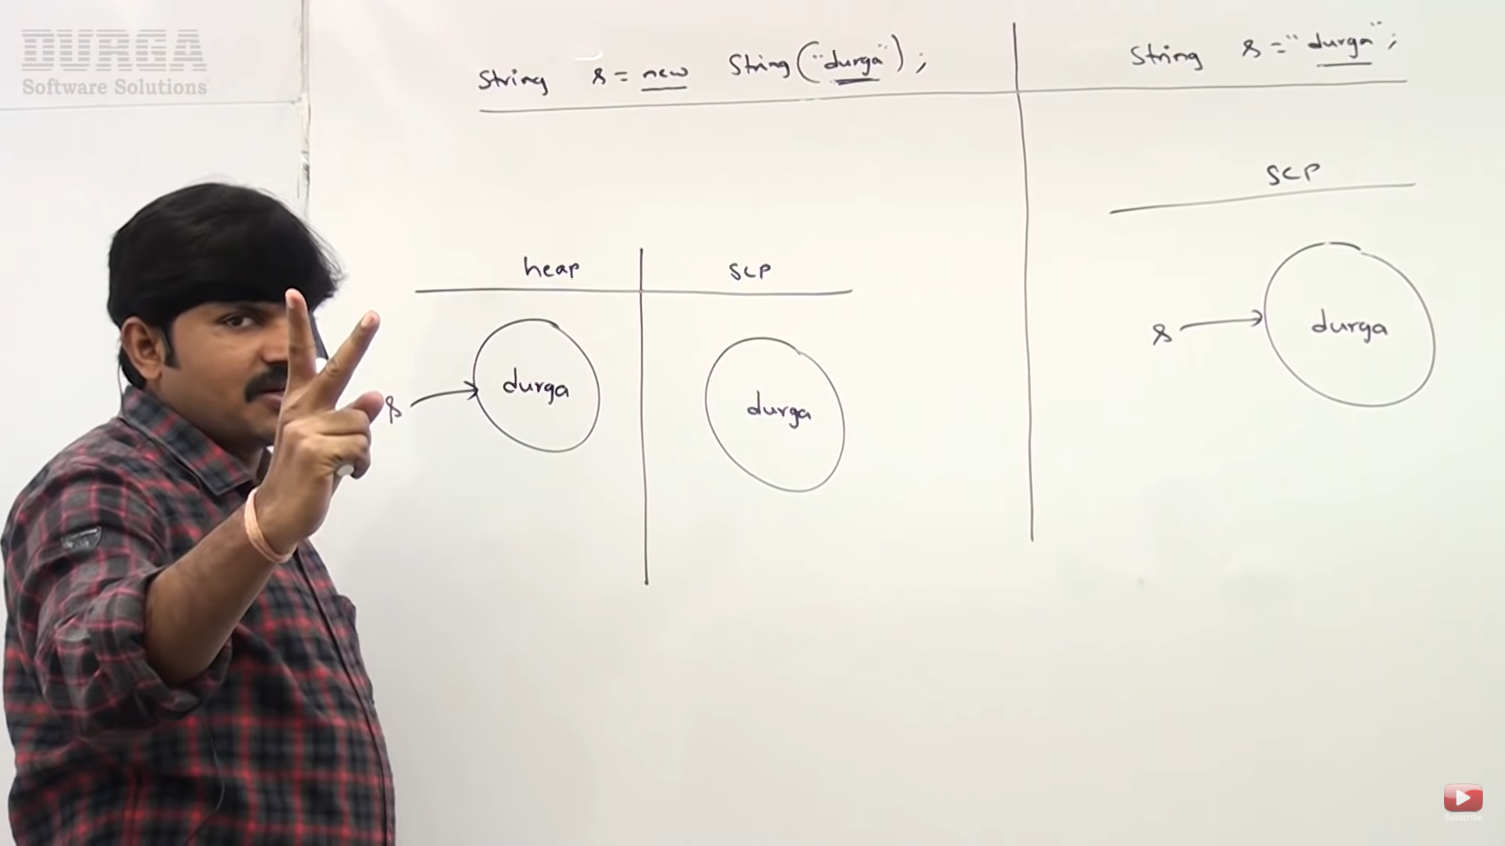

In 1st case, two objects will be created. Due to the new operator used, compulsory an object will be created in the Heap area with content ‘Durga’ and ‘s’ is the reference variable for this. Also, ‘Durga’ is a literal, so a new object will be created for this literal in SCP (String Constant Pool) area and for this object, internally JVM will implicitly create a reference variable so this will not be garbage collected. The need of this (SCP Object) is reusing same objects for future purpose. Until 1.6 version, SCP was part of method area / PERMGEN but after 1.7 version, the SCP is a part of heap only for efficient memory utilization. In PERMGEN SCP was of fixed size but in Heap, the size of SCP can be expanded.

In 2nd case, only one object will be create in the SCP area. But first JVM will check if there is any object with same content in SCP. If it is there it will reuse the same object.

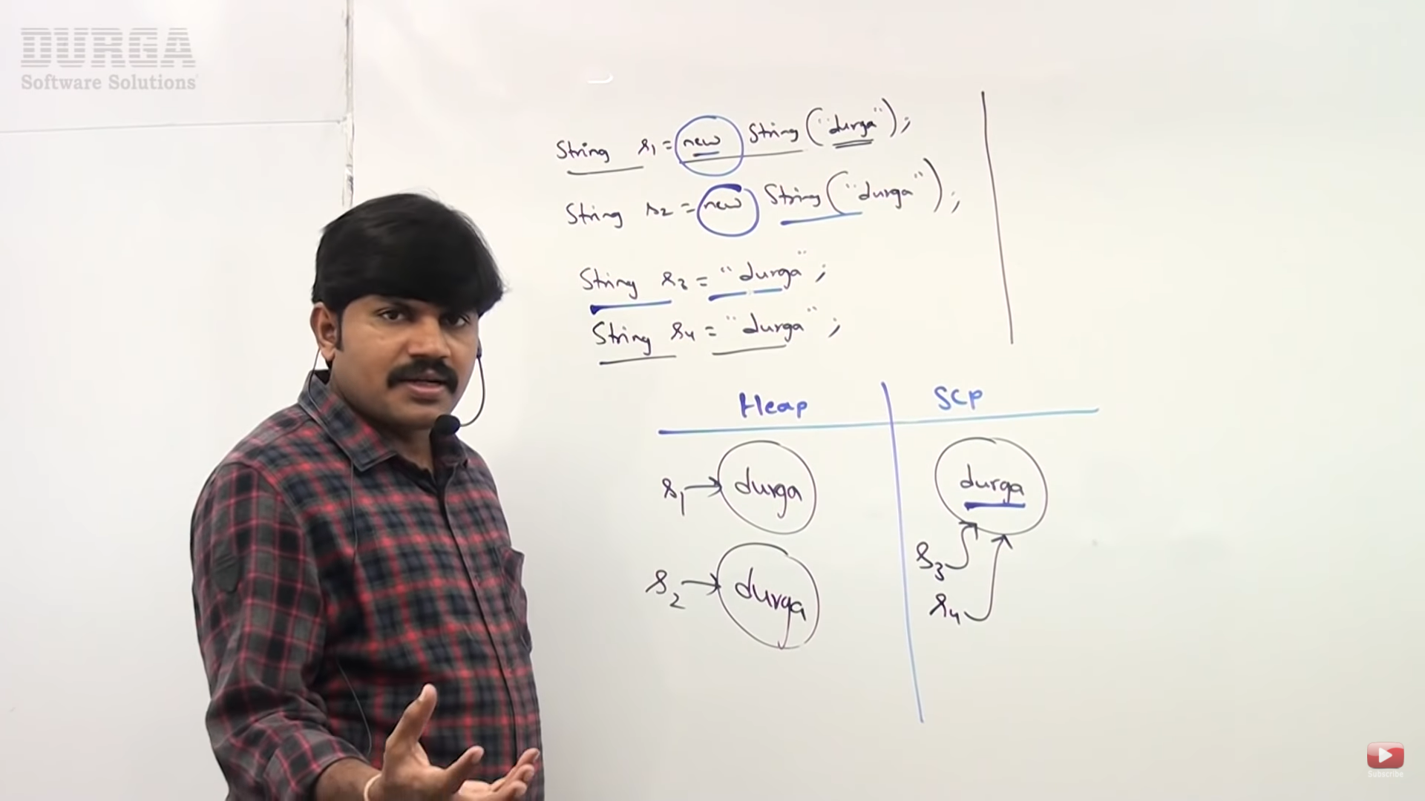 2 objects in Heap and 1 object in SCP. So, there may be objects with same content in the Heap area but not in SCP. Note: Here s1 points to Heap object and the JVM will create a diff reference object for literal in SCP while s3 points to a the literal in SCP. So s1 ans s3 are not same.

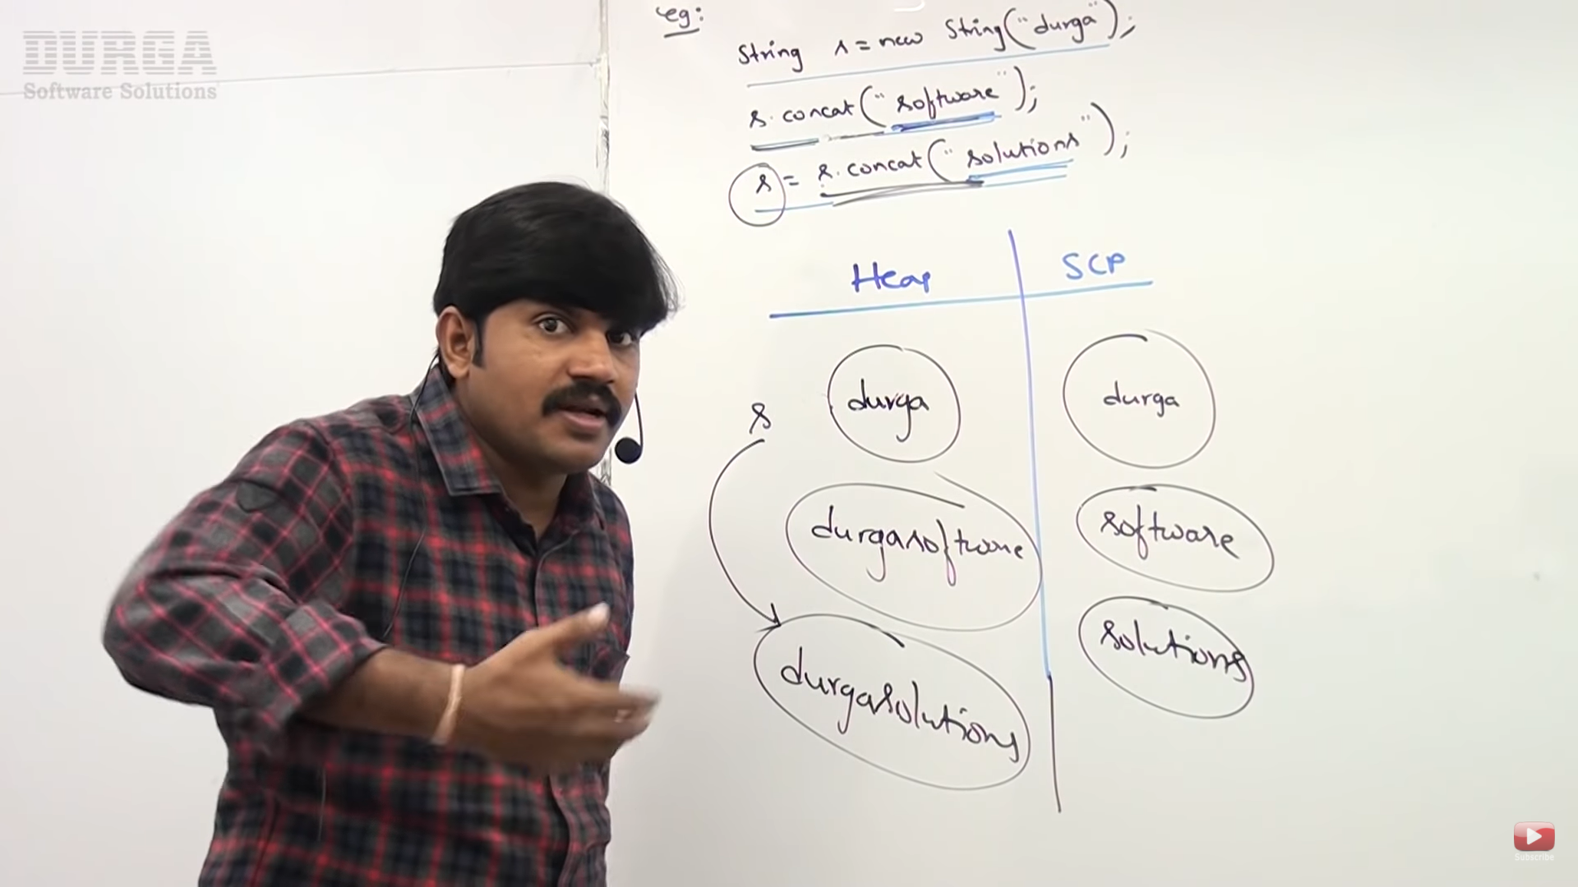

For every literal, an object will be created in the SCP. We know String is immutable and if we try to change the content a new object will be created. Because of runtime operation, if an object needs to be created, it will always be created in the Heap area and not in the SCP (example of this is the concat method used). 6 objects got created and out of that 2 from Heap will be Garbage collected.

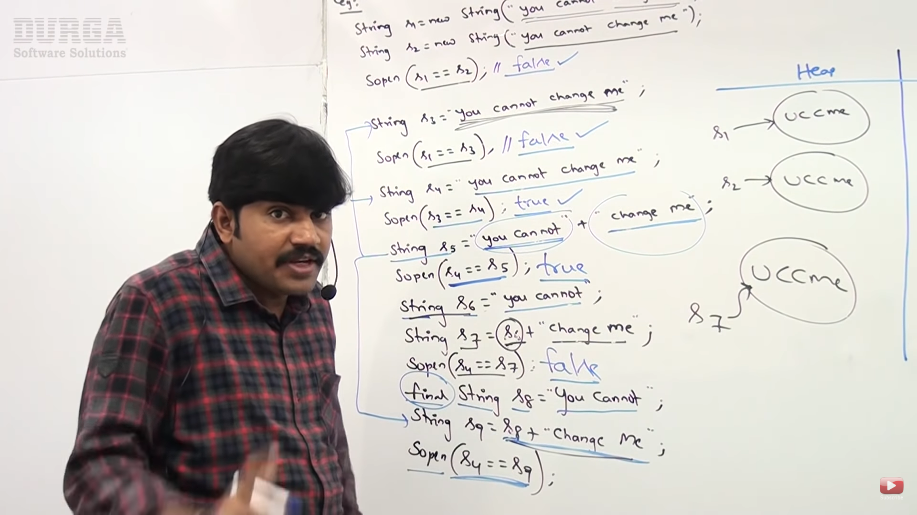

In s5, since both the arguments are constants, the concatenation will happen at compile time and not at runtime. So, a new String will not be created in the SCP and it will be same as s4.

In s7, since one argument is variable and other constant, the value for s7 will be determined at Run time.

We know that the value of all final variables will be replaced at compile time. So, in s9, the s8 variable will be replaced by the value of s8 at compile time and hence s9 will be calculated at compile time.

ADVANTAGE/IMPORTANCE OF STRING CONSTANT POOL:

In any application most commonly used object is String Object only.

If any object is required repeatedly, it is never recommended to create separate object for every requirement. For ex: For voter registration Form, there are several fields in the form like State, Name, and address. If there are 3 lacs voters from Hyderabad, it is not good to create 3 lacs objects of Hyderabad for each Voter since it can cause performance issues and object creation will be costly as well and memory will be wasted. Instead, we can have just one object and share it with others. This is possible because of SCP.

1. Same/Single object can be referenced with multiple references. Biggest advantage
2. Memory Utilization will be improved

Dis-Advantage: Immutability concept is required because of SCP only. If SCP is not required, we will not need immutability.

In above ex if a person from 3 lacs voter changes his state name, it will reflect in other voters as well since initially all of them pointed to same object (Using one reference all others references will be affected). So, to handle this immutability was introduced. In this if a person tries to modify a String, a new object will be created and the reference of that person / object will be pointed to the new object and the other objects will be same and their references pointing to the initial object only.

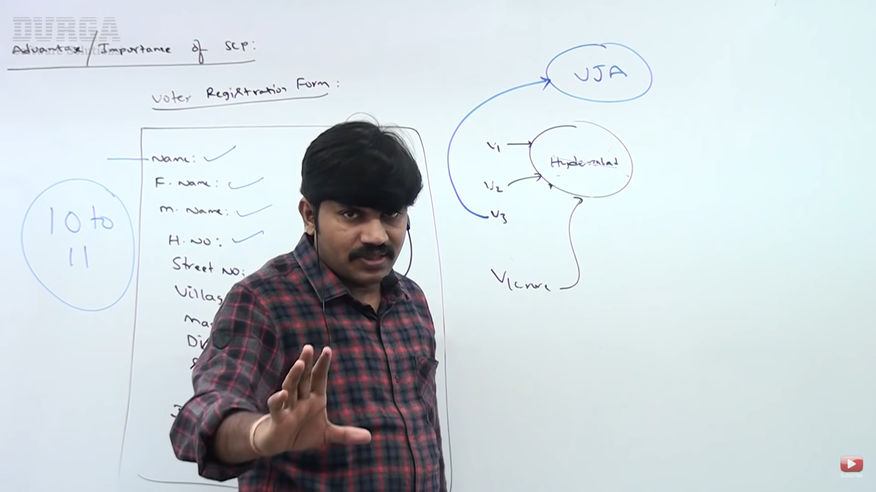

FAQs IMPORTANT:

1. Why SCP concept is available only for String Object but not for StringBuffer? -- > The most commonly used object in Java is String. So for String Special privileges are there (Special memory management provided by Java) while StringBuffer is less frequently used.
2. Why String Objects are immutable whereas StringBuffer objects are not immutable? -- > In String, because of SCP, same objects can be used multiple times. By using one reference, if we change the content, the remaining references will be affected. So, once we create String object we are not allowed to change its content. Since this content is shard with multiple references, if anyone tries to change it, with those changes a new object should be created. So, because of SCP immutability is required. In StringBuffer, reusing same object is not there. Each object in StringBuffer has separate reference, so if we change content of one object others will not be affected. So immutability is not present in StringBuffer.
3. In Addition to string objects, are there any other objects which are immutable in Java? -- >

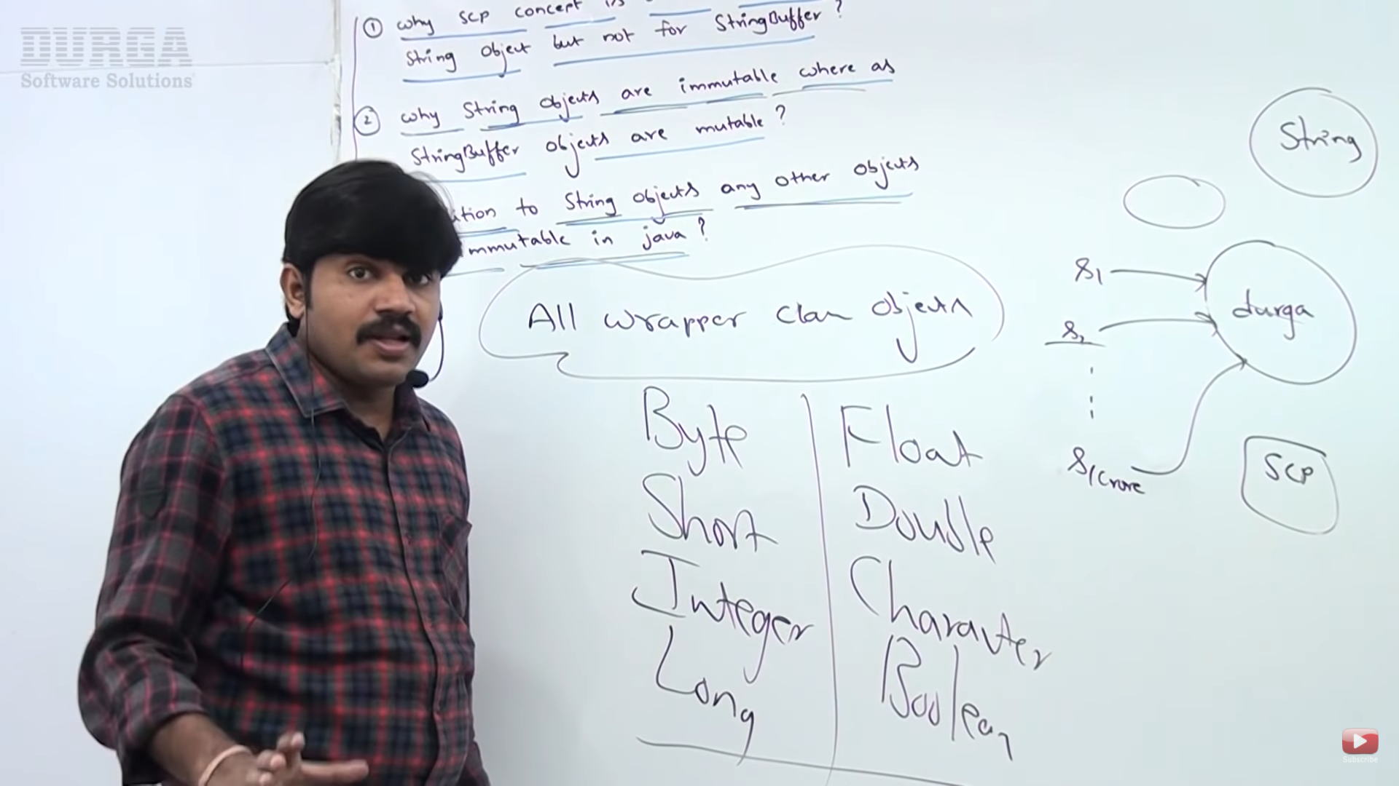

IMPORTANT CONSTRUCTORS IN STRING CLASS:

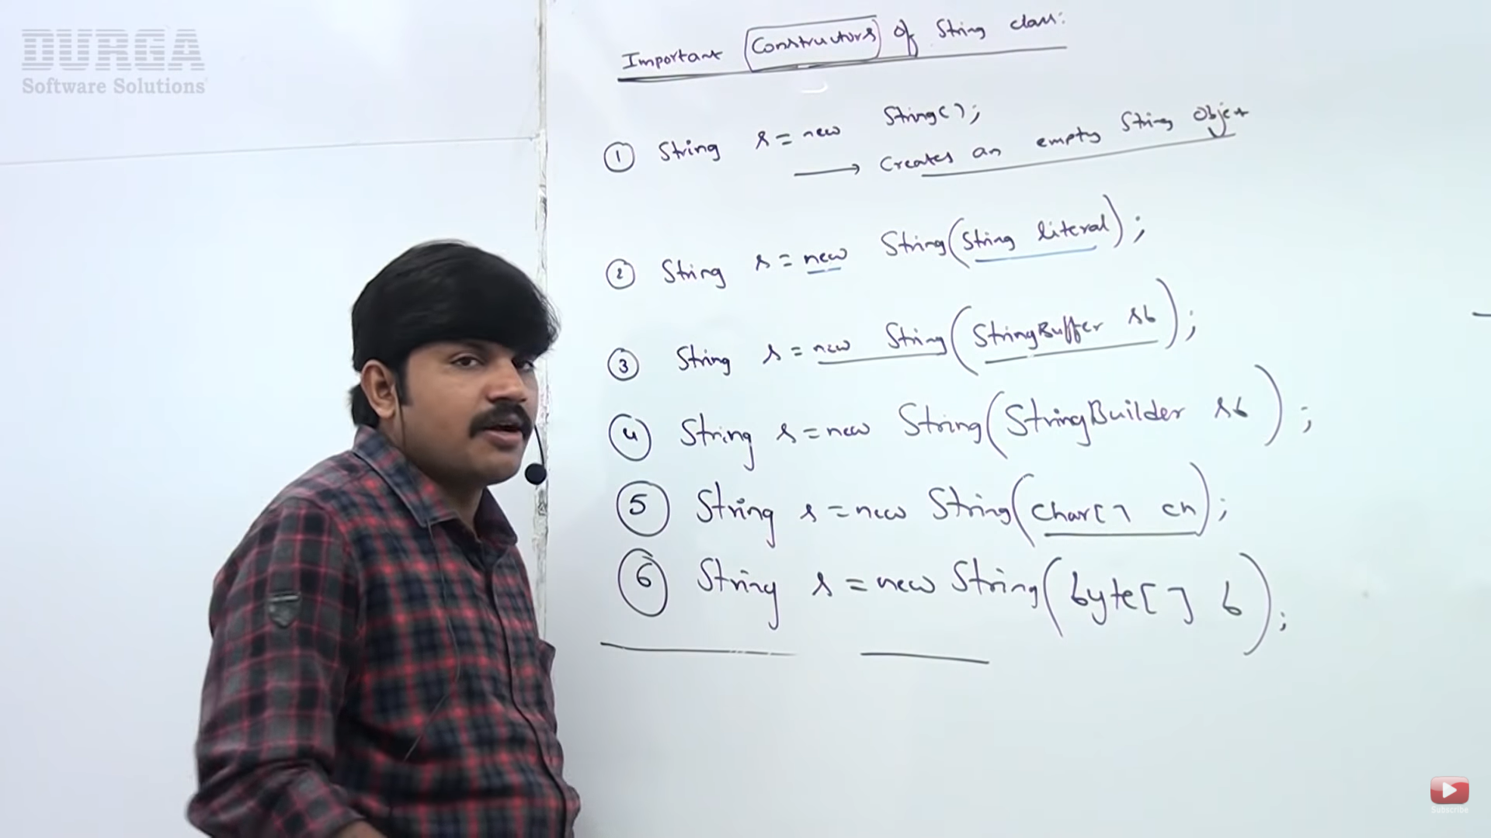

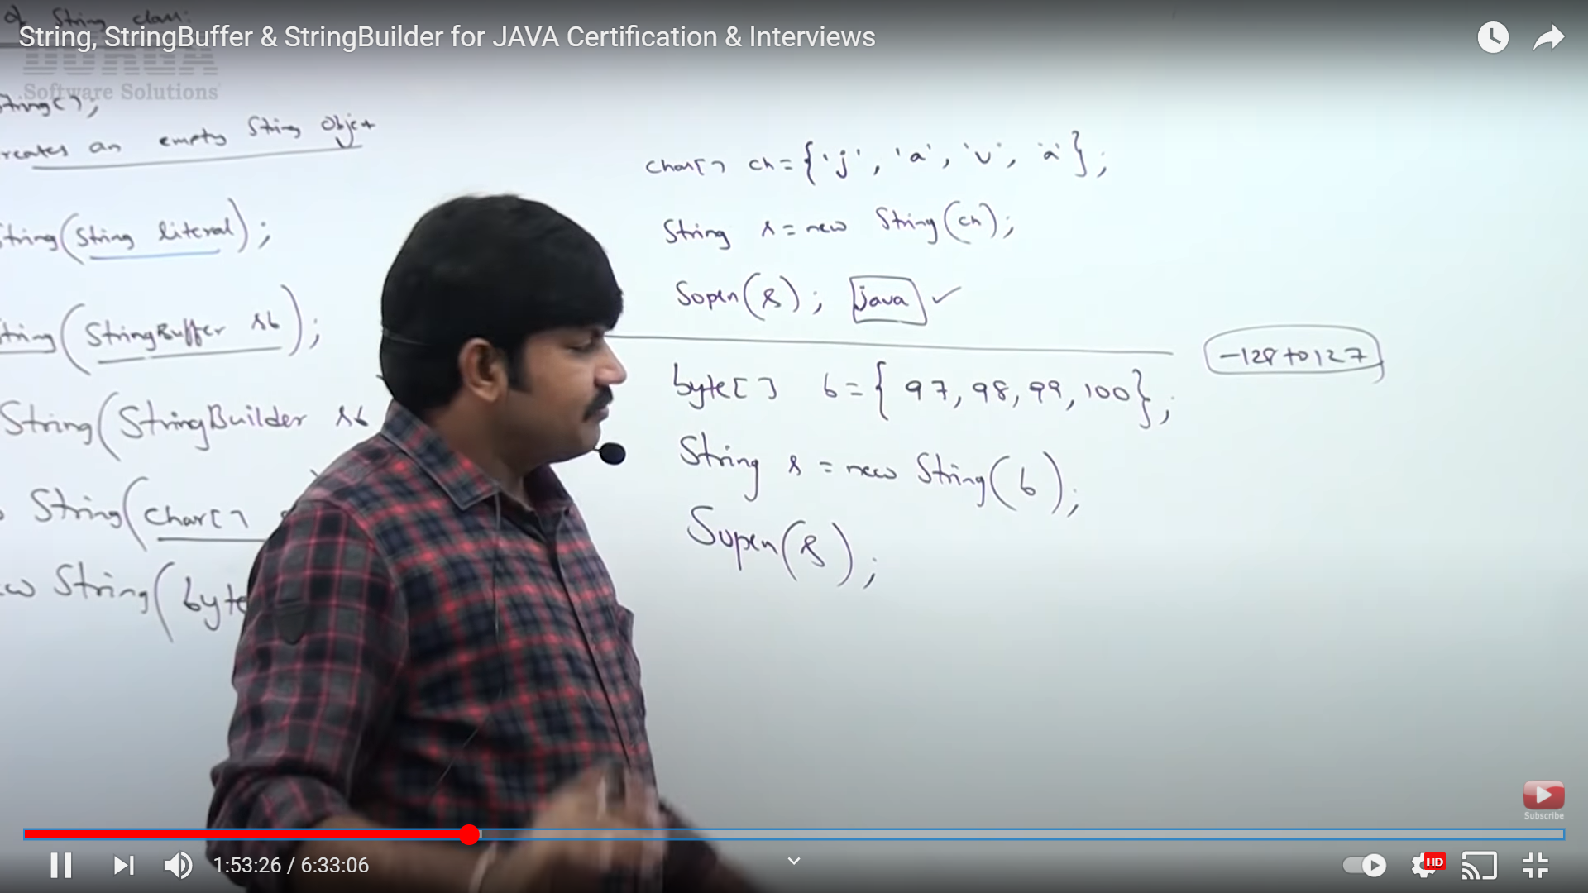

IMPORTANT METHODS OF STRING CLASS:

|  |  |
| --- | --- |
| public char charAt (int Index) |  |
| public String concat (String s) | We can use operator as well as an alternative to this runtime method. |
| public Boolean equals (Object o) | To check equality of String objects.( Case included) |
| public Boolean equalsIgnoreCase (String s) |  |
| public Boolean isEmpty (String s) |  |
| public int length (String s) |  |
| public String replace(char old, char new) |  |
| public String substring(int bgnIndex) | From index bgnIndex to end of the String |
| Public String substring(int bgnIndex, int endIndex) |  |
| Public int indexOf(Char c) | If char available then -1 is returned. If char present at multiple locations, then 1st occurrence is taken |
| Public String toLowerCase( String s) |  |
| Public String toUpperCase( String s) |  |
| Public int lastIndexOf(Char c) |  |
| Public String trim () | Removes spaces at beginning and end of the String. |

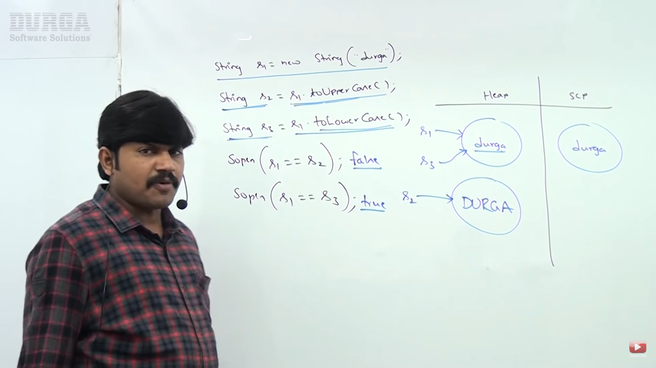

Once we create String object, we are not allowed to perform any changes. If a person tries to make any changes, if there is a change, then with those changes a new object will be created. If there is no change, then existing object will be reused. This applies for both Heap as well as SCP whether the existing object is present in Heap or SCP. ~~Conflict for above and below image~~

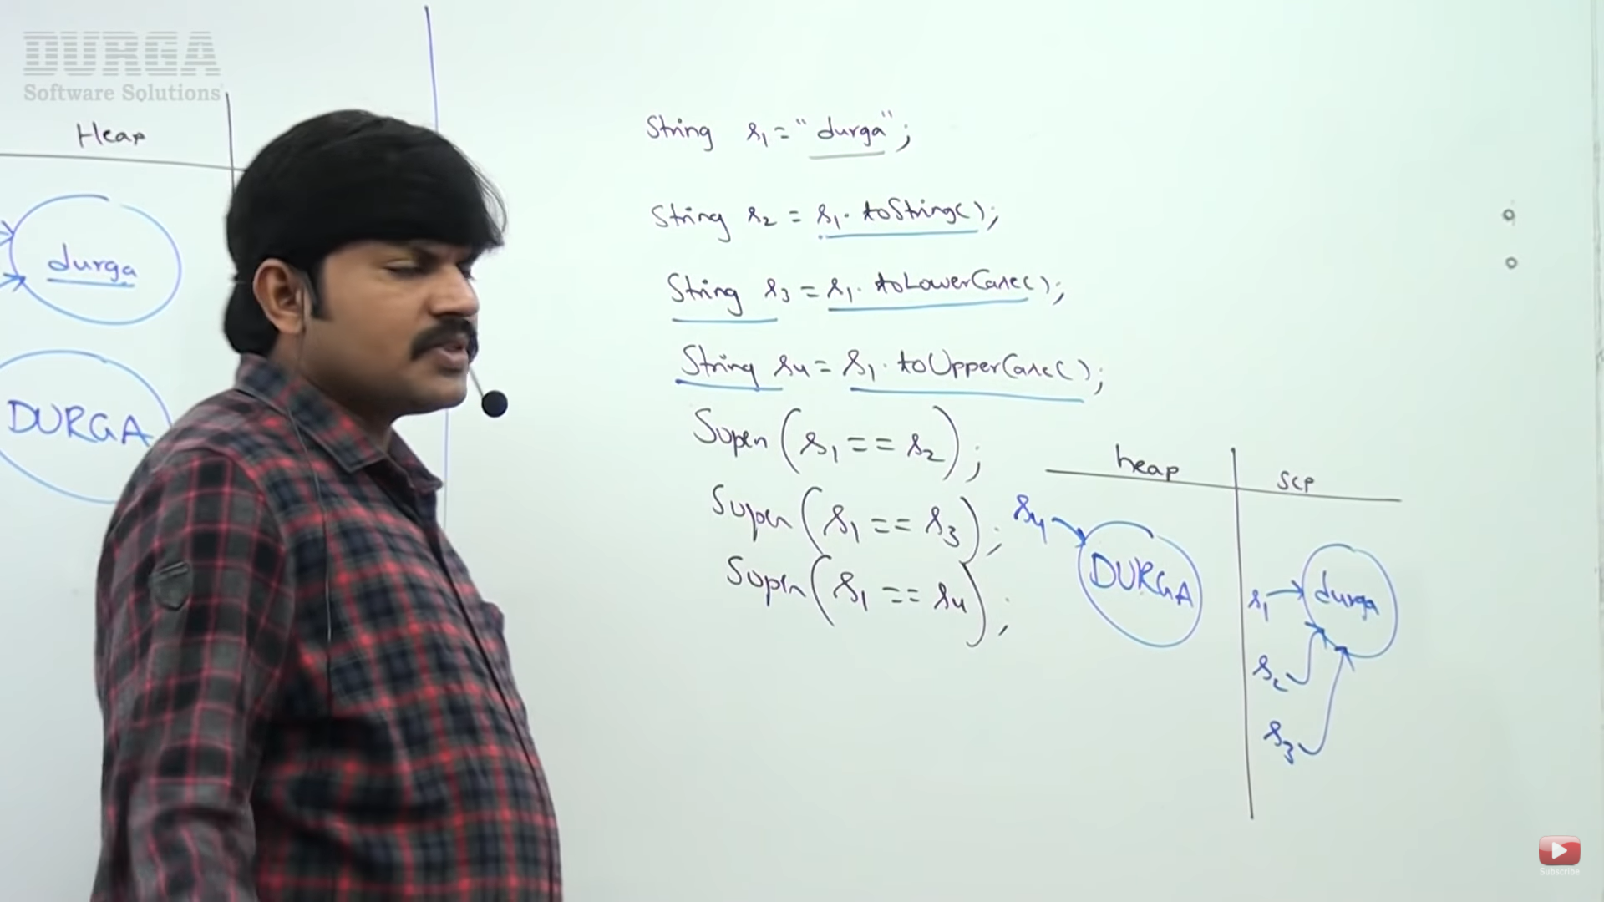

CAN we create our own IMMUTABLE class?

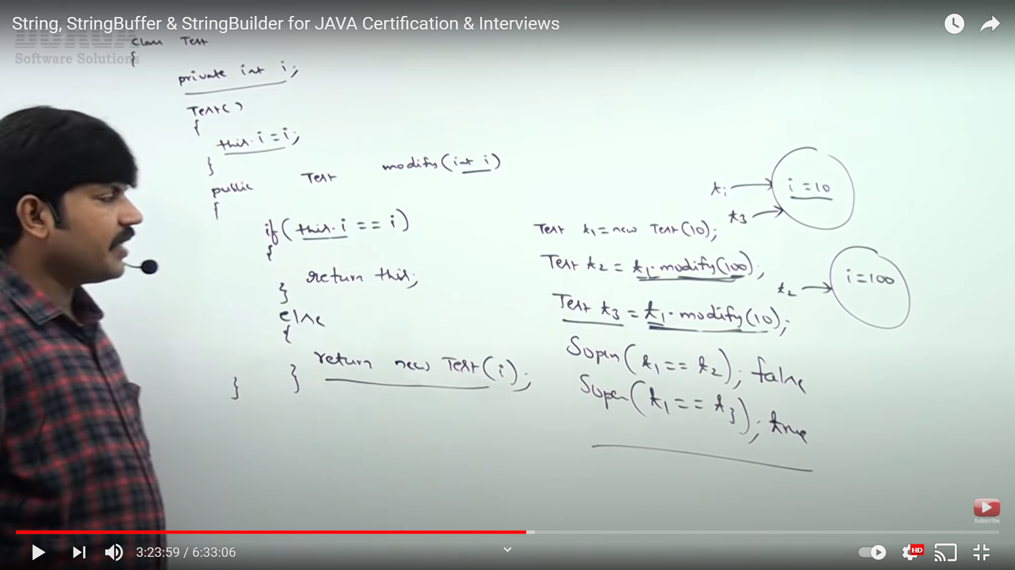

Because of modify method, TEST class will become immutable. In String class, every method is declared in this way. So, it is immutable. As we cannot change the contents of these methods, we can declare the class as final. So, all the wrapper or immutable classes are final class – String, Integer, Boolean etc. No one is allowed to override and change its content.

FINAL VS IMMUTABILITY – Both are not same

It is wrong that we can make a StringBuffer object as immutable by making it final. But both are not same. Immutability is related to object while final is related to reference variable. If we declare a StringBuffer object as final, it does not become immutable (we cannot change anything in that object is the definition of immutable). We can modify the contents inside the object, but we cannot reassign it to a new object i.e. we cannot change the reference of this final object. The below code will give error since we are reassigning the final variable. But the append will work as expected and will modify the sb object.

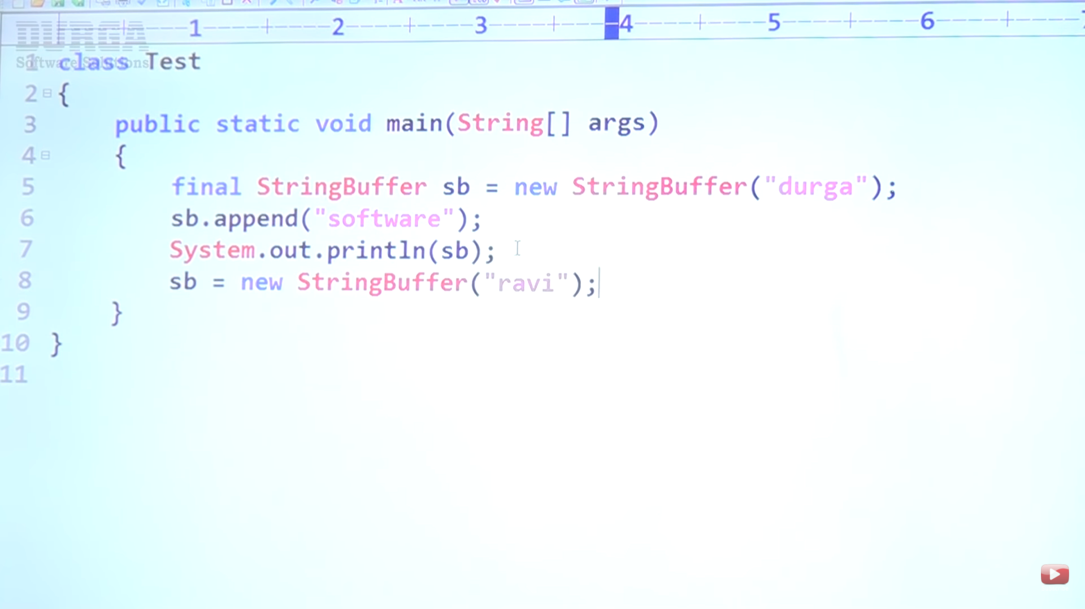

Note: Which of the following is meaningful?

1. Final variable
2. ~~Final object~~
3. ~~Immutable variable~~
4. Immutable object

**So, final is applicable for variable and immutability for objects.**

STRING BUFFER

When the content keep on changing, it is recommended to use StringBuffer compared to String since for each new change, String class creates a new object. With StringBuffer, all the changes made will be done in the same object only.

CONSTRUCTORS OF STRINGBUFFER:

1) StringBuffer sb = new StringBuffer (); -- > Default initial capacity for StringBuffer is 16. If a 17th Character is added, new capacity will be (16+1)*2. A new bigger object will be created with capacity 🡪 (Current Capacity + 1) * 2. The reference will point to this new object and the old object will be Garbage collected. In this performance will be down if a new object is created each time.

2) StringBuffer sb = new StringBuffer (int initialCapacity); --Creates a bigger StringBuffer object at start itself.

3) **StringBuffer sb = new StringBuffer (String s)**; -- > The capacity of this StringBuffer created is s.length() + 16 (Default capacity).

IMPORTANT METHODS OF STRINGBUFFER:

|  |  |
| --- | --- |
| public int length (); |  |
| public int capacity (); |  |
| public char charAt (int index); | If index > length, then StringIndexOutofBound thrown |
| public void setCharAt(int index, char newChar); |  |
| public StringBuffer append(T t); | T can be String, byte, int, long, float. We have method overloading for append method. Append will add data at the end position |
| public StringBuffer insert(int index, T t); | T can be String, byte, int. So it is too a multiple overloaded method.  Used to add data at any specific location. |
| public StringBuffer delete (int begin, int end); | Deletes data from begin to (end-1) index. |
| public StringBuffer deleteCharAt (int index); |  |
| Public StringBuffer reverse(); |  |
| public void **setLength**(int length); | If a StringBuffer contains huge content and you require first x characters. Rest others characters will be removed if present.  Ex: Sanket --- > length == 3 ---> San |
| public void **ensureCapacity**(int capacity); | Based on requirement if we want to increase capacity dynamically. |
| public void **trimToSize**(); | To deallocate extra allocated memory. |

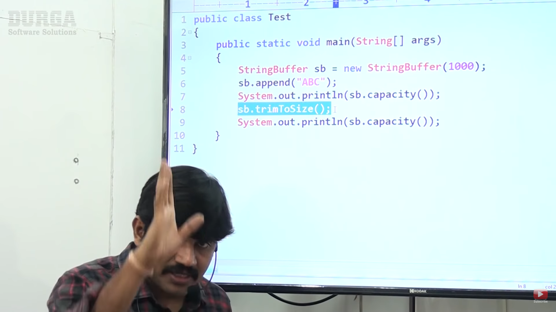

After adding string of length 3 and increasing the size to 100, if we decide not to add any more characters, the rest space will be wasted for chars 997. To deallocate this space, we can use trimToSize ();

STRING BUILDER:

**Problem with StringBuffer**: Every method present inside StringBuffer is synchronized. So at a time, only one thread is allowed to execute the methods. As a result waiting time will be increased and performance will degrade.

So to overcome this problem, in 1.5v StringBuilder is introduced.

All methods, constructors are same in StringBuilder as they were in StringBuffer. The only change made is replaced Buffer keyword to Builder at all places and removed synchronized keyword.

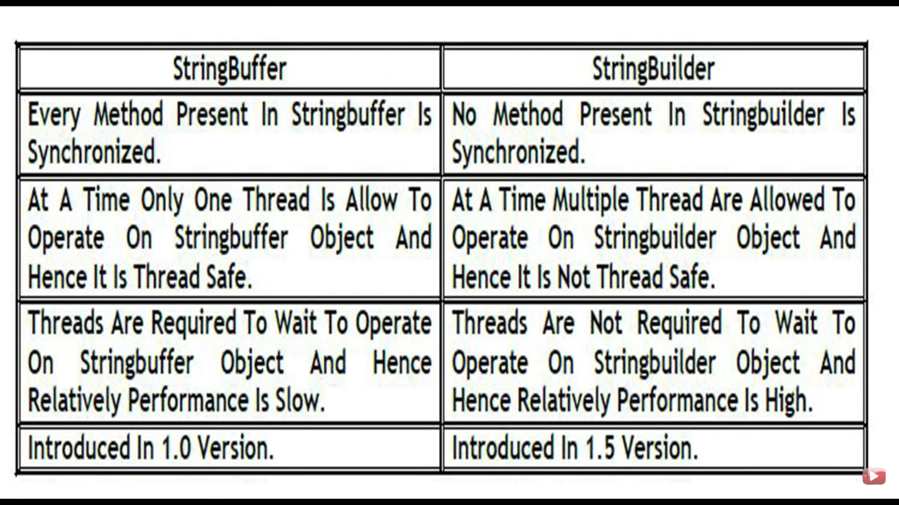

String Buffer and String objects are thread safe. Only one thread can operate on one object of StringBuffer while no thread is allowed to do any change on String object. So, it is also thread safe.

String —> Use when content is fixed and changes less no of time

StringBuffer -- -> Use when content changes frequently and you want thread safety

StringBuilder -- -> Use when content changes frequently and you do not want thread safety

METHOD CHAINING:

For most methods present in String, StringBuffer and StringBuilder class, the methods have same return type.

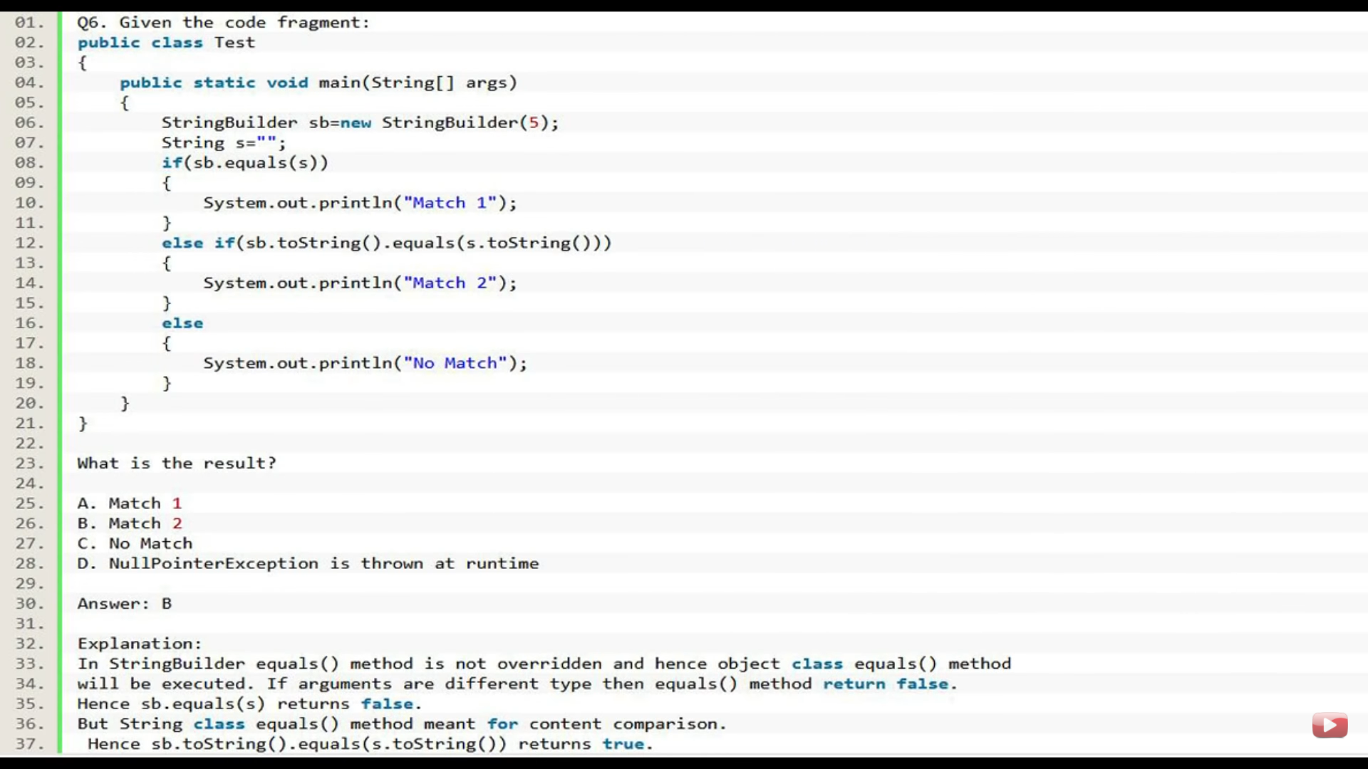

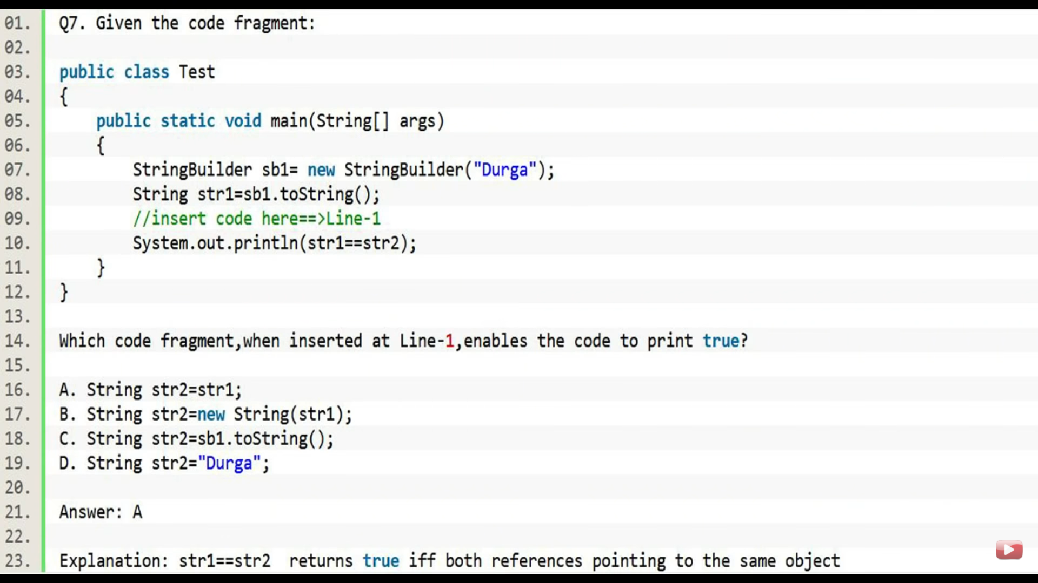

For b, a new object will be created in Heap. For c, a **new String object will be created in Heap**. For option d, a String object s4, will be created in SCP. Because of method call, if an object needs to be created, compulsory the object will be created in Heap area. Note: A StringBuffer will always create a new String object in Heap when called toString ().

Whenever we try to print any object reference, internally toString() method will be called. If the class does not contains a toString(), then Object class toString() method will be called. In String class, StringBuffer class, all wrapper classes, all Collection classes, toString() is overrided.

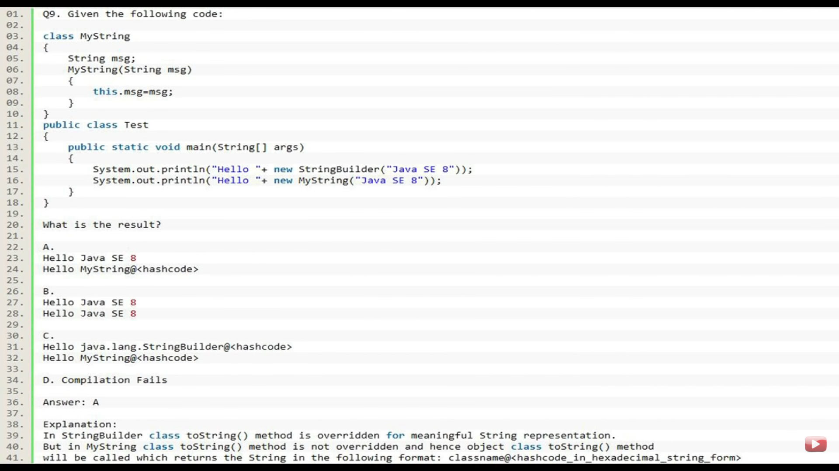

In A -- > Create sb object, Substring object will be GC. Sb will point to original number. Total thing will be appended. **Substring used over sb object will return a string. This string will need a reference to be held by whereas append and other StringBuilder methods will return the reference to the object only. So append will result in the change in the object while substring will not**.

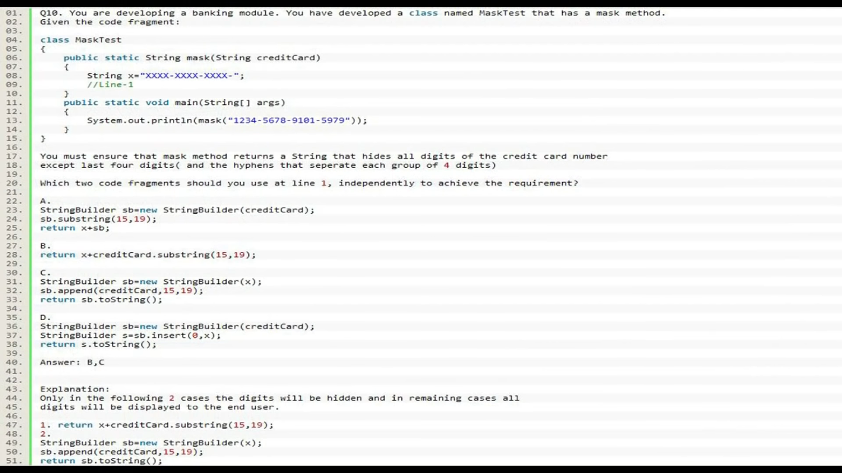

|  |  |
| --- | --- |
| STRING | SRIGN BUFFER |
| Immutable | Mutable |
| Equals methods does content comparison | Equals methods does reference comparison |

MAIN METHOD:

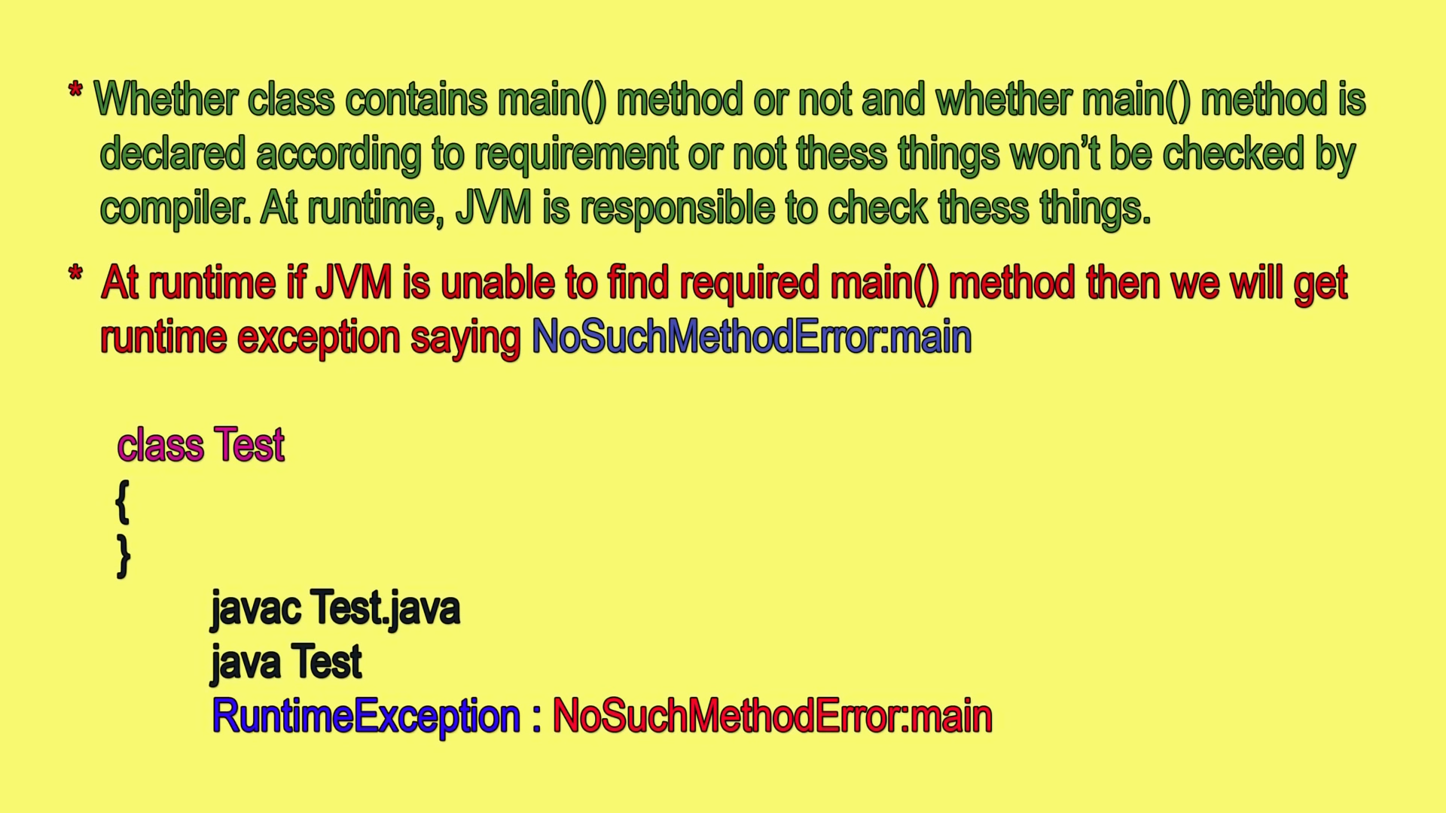

JVM will start the execution from the main method itself. Internally, it is configured for JVM to search for main method having this syntax only. So, we can change name of main method, but customization of JVM will be required.

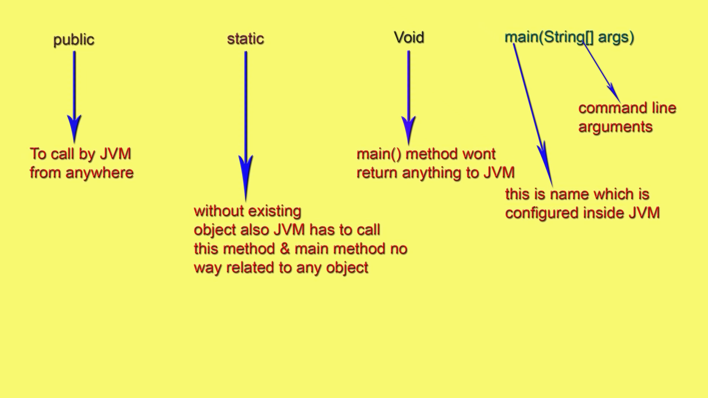

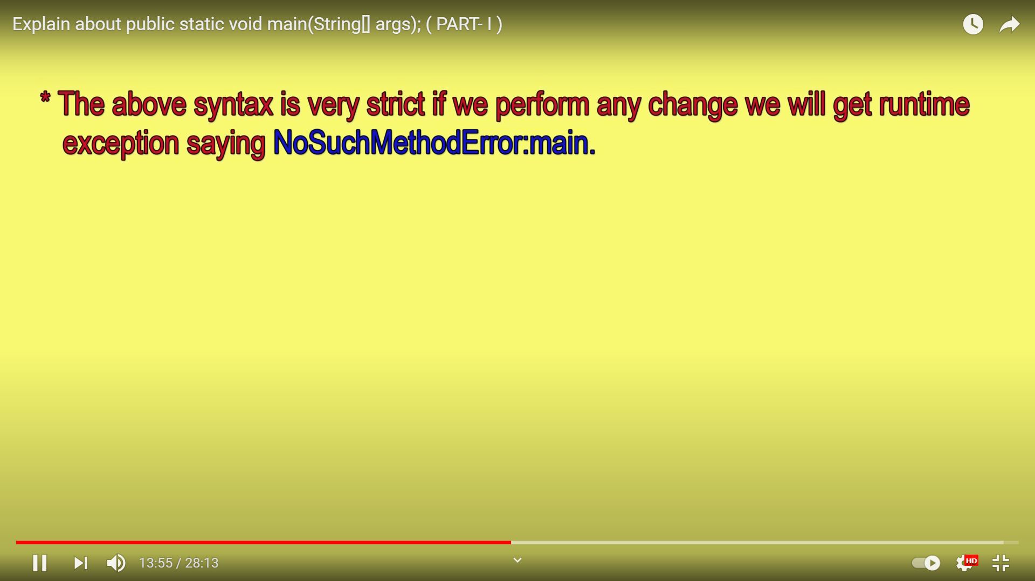

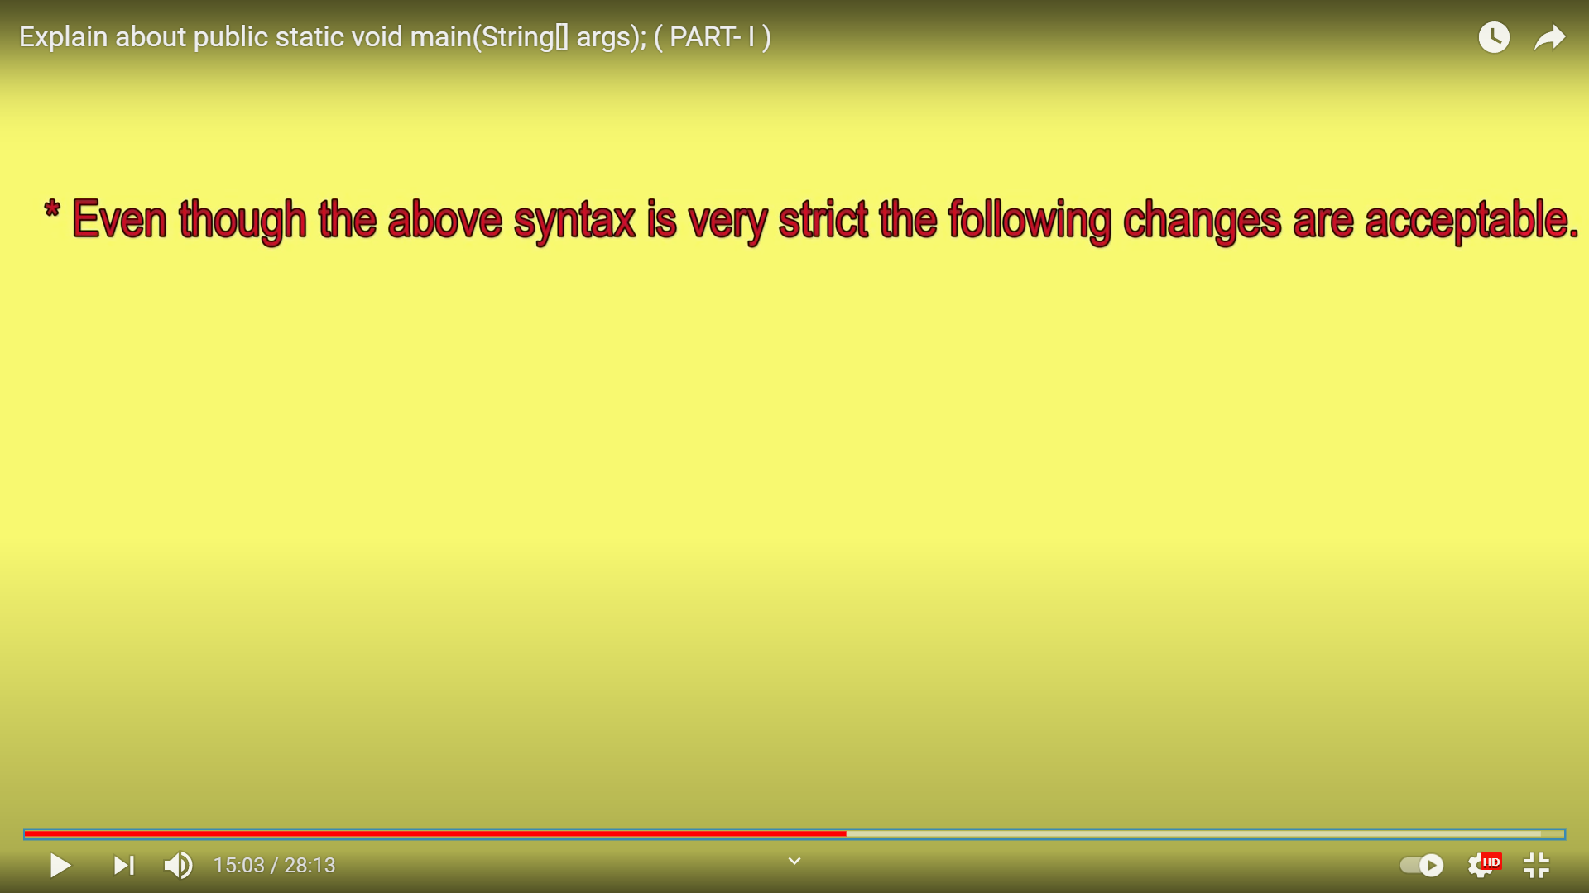

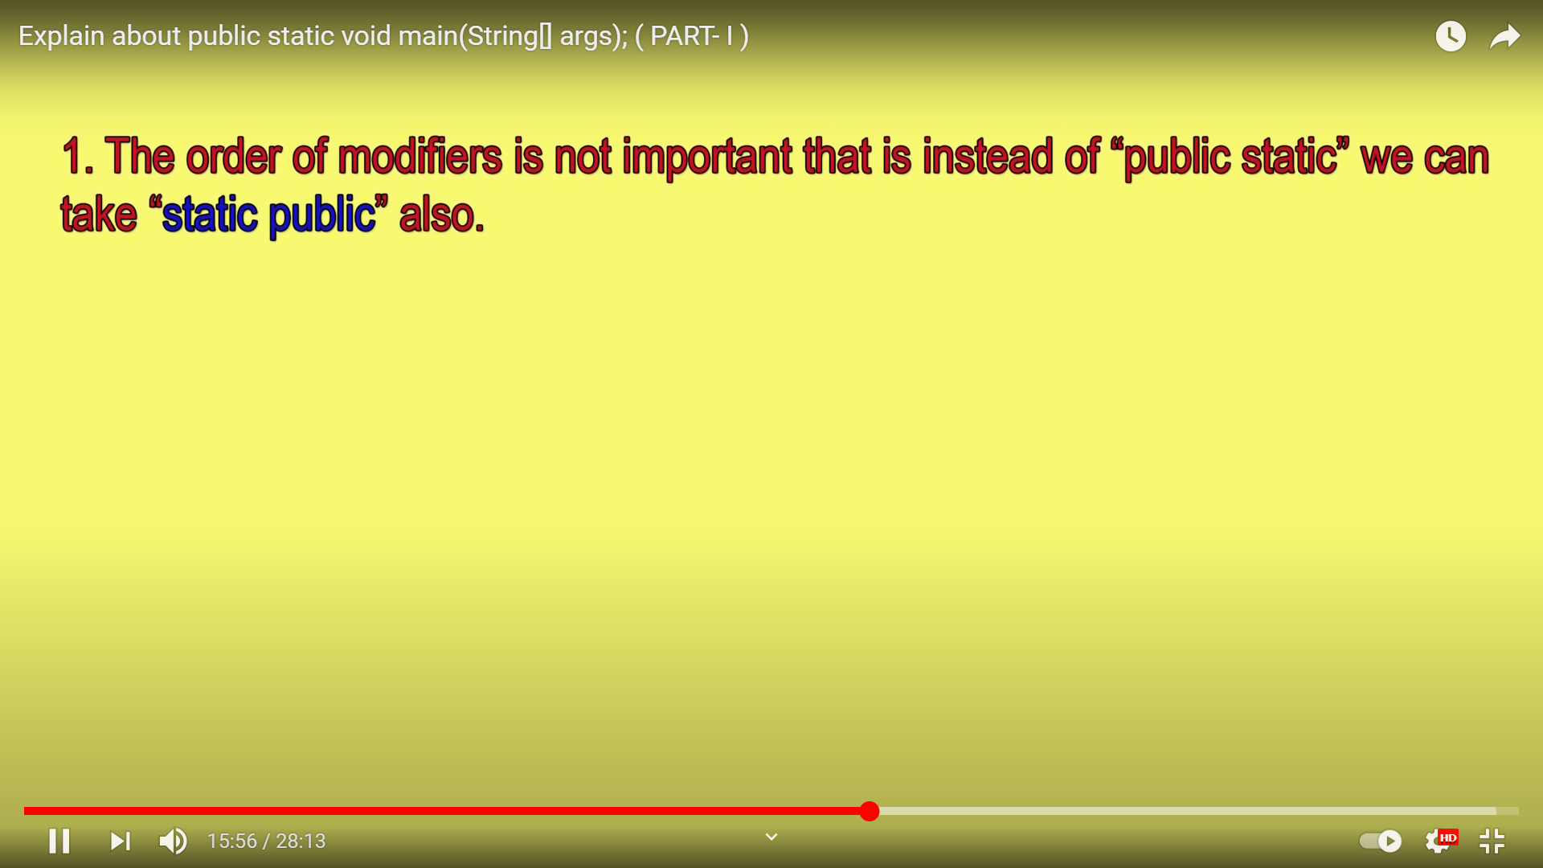

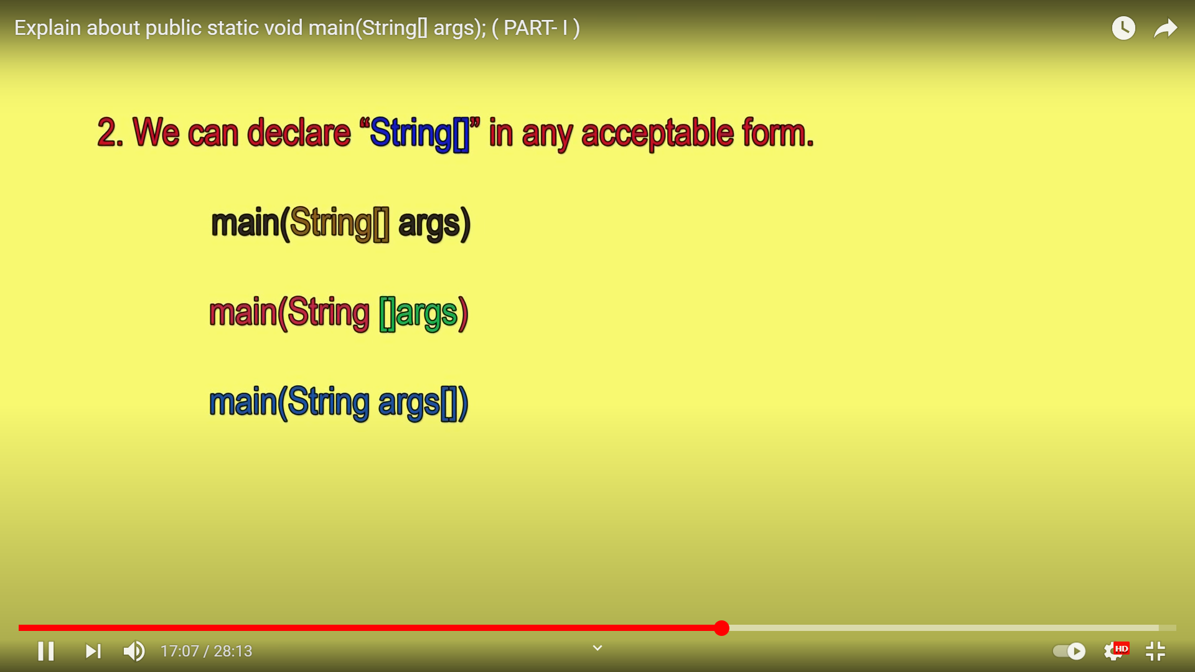

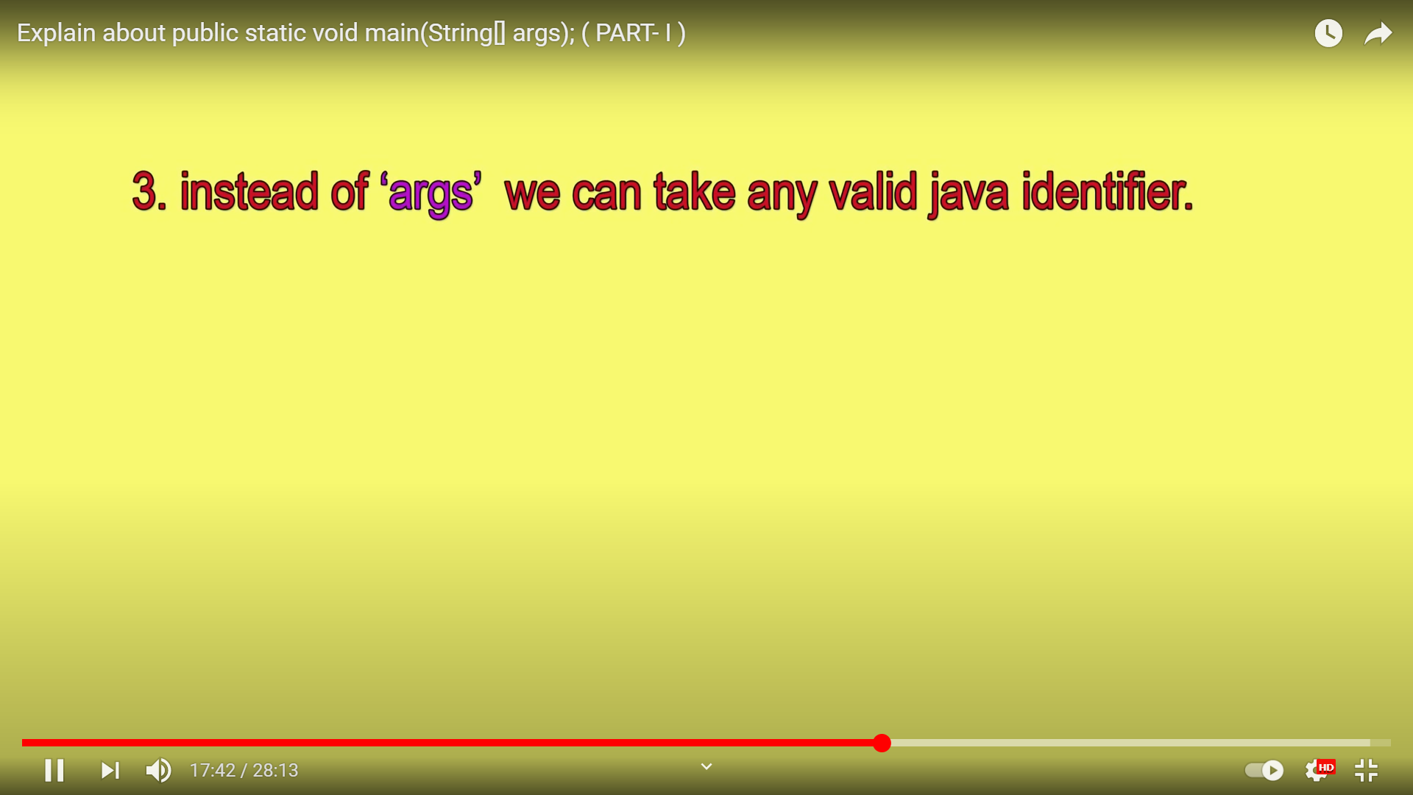

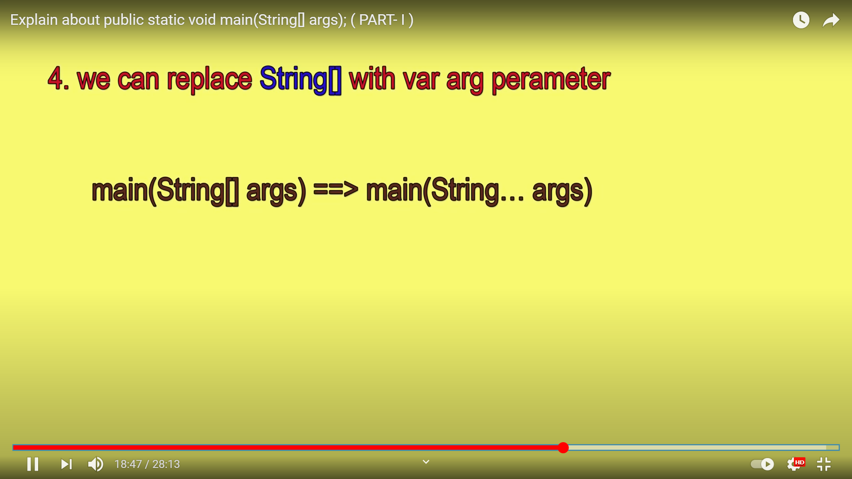

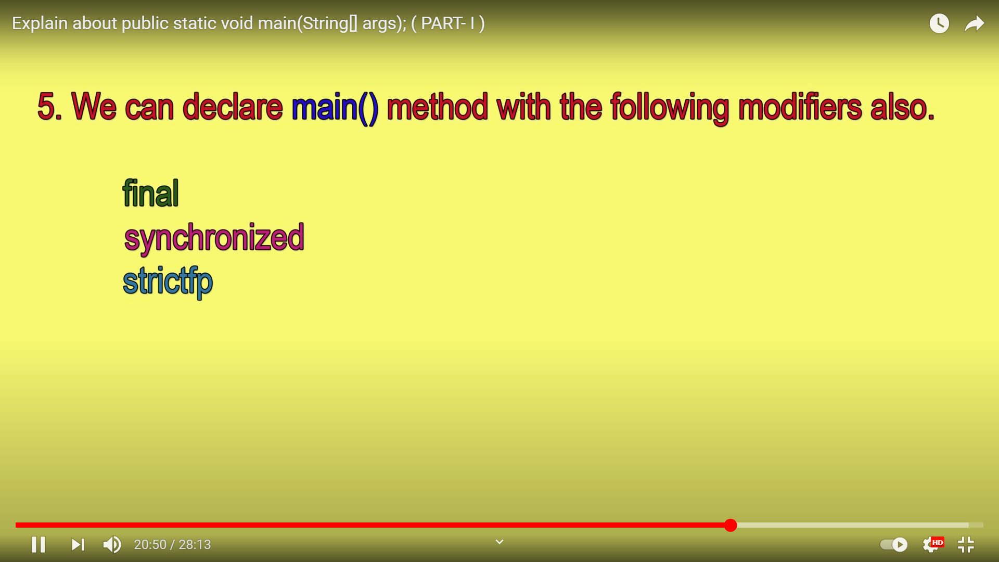

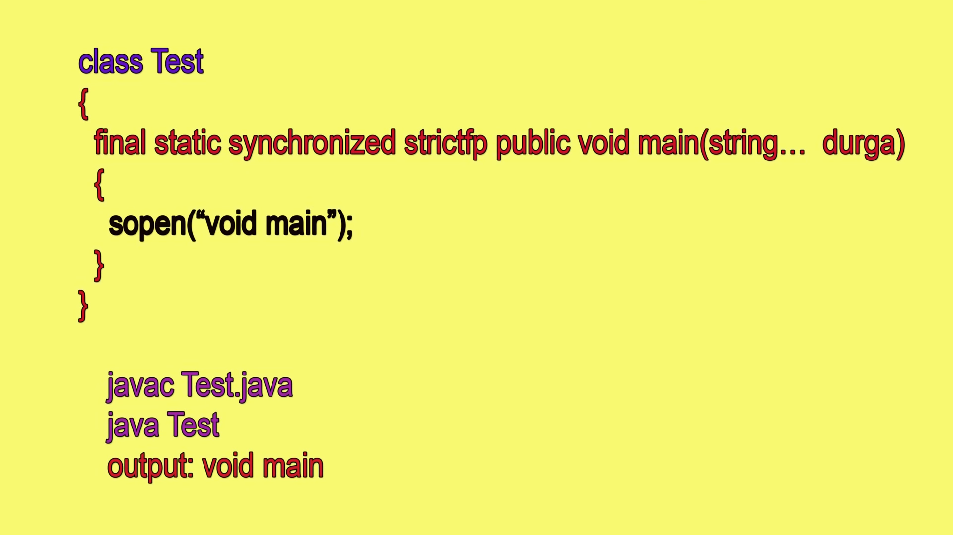

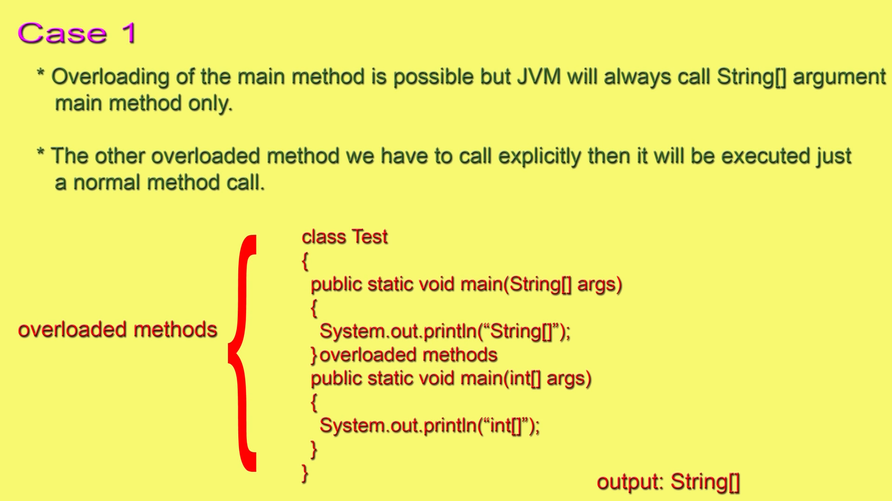

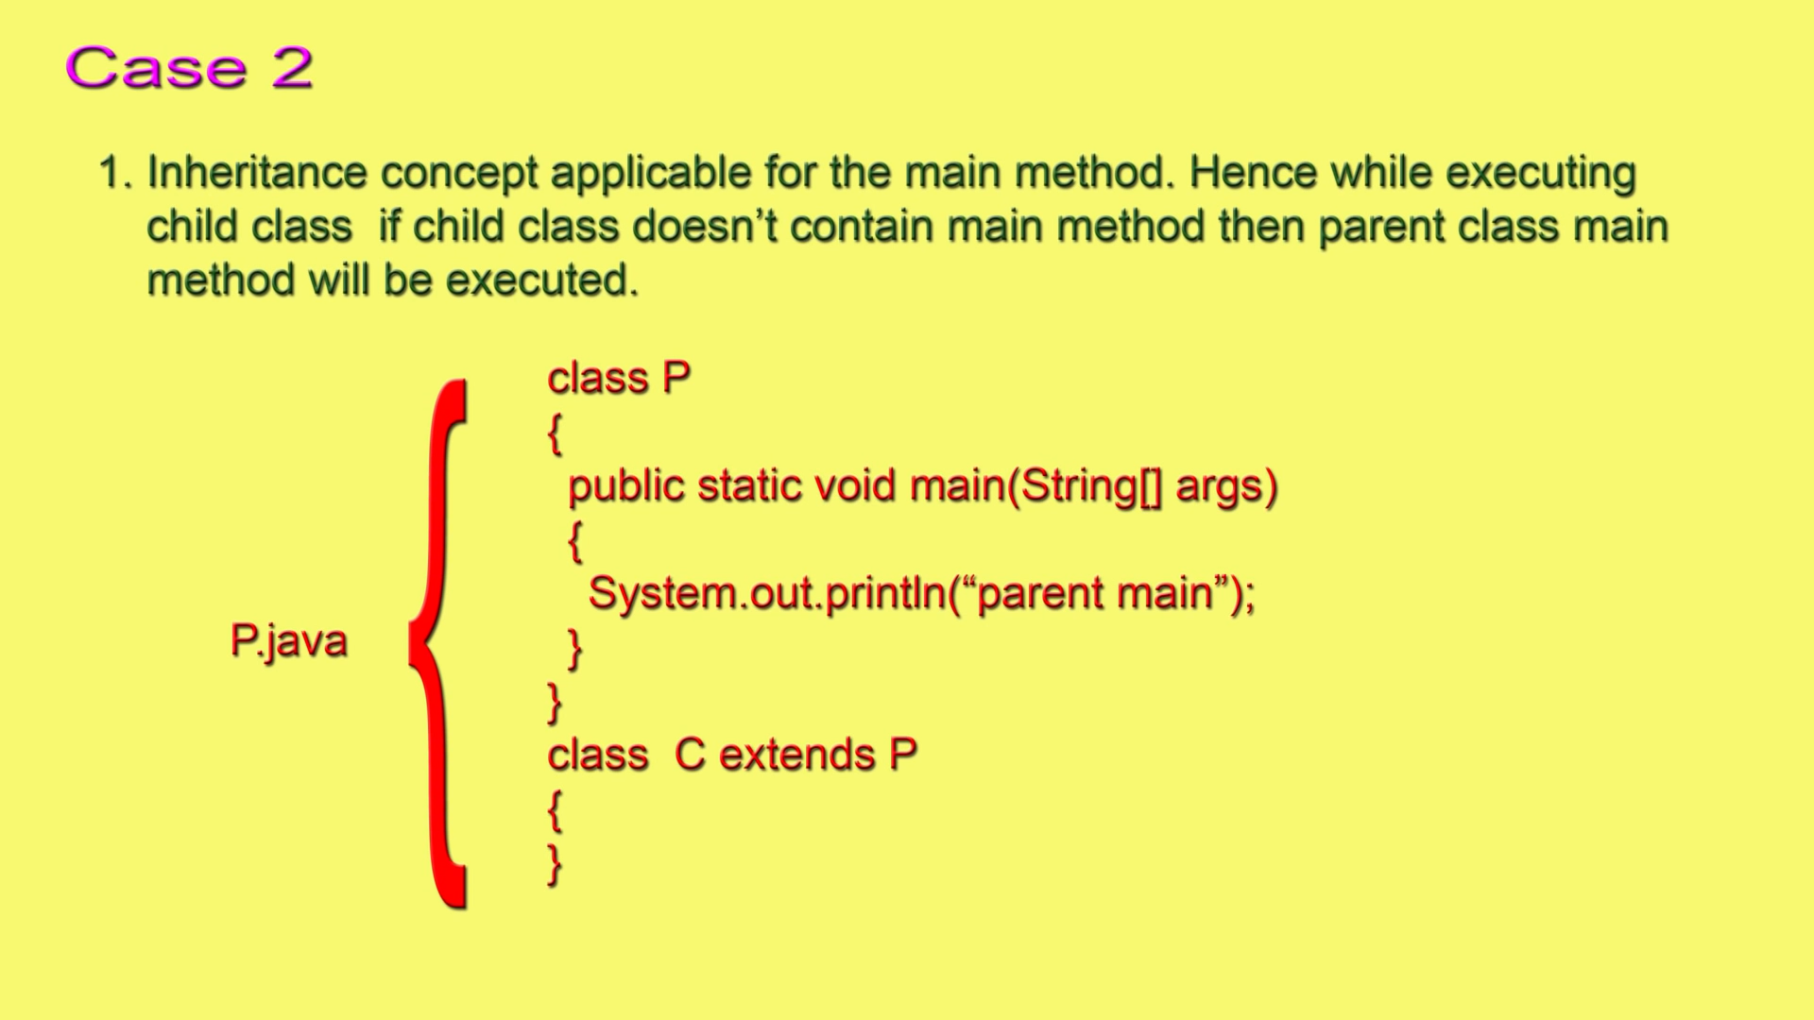

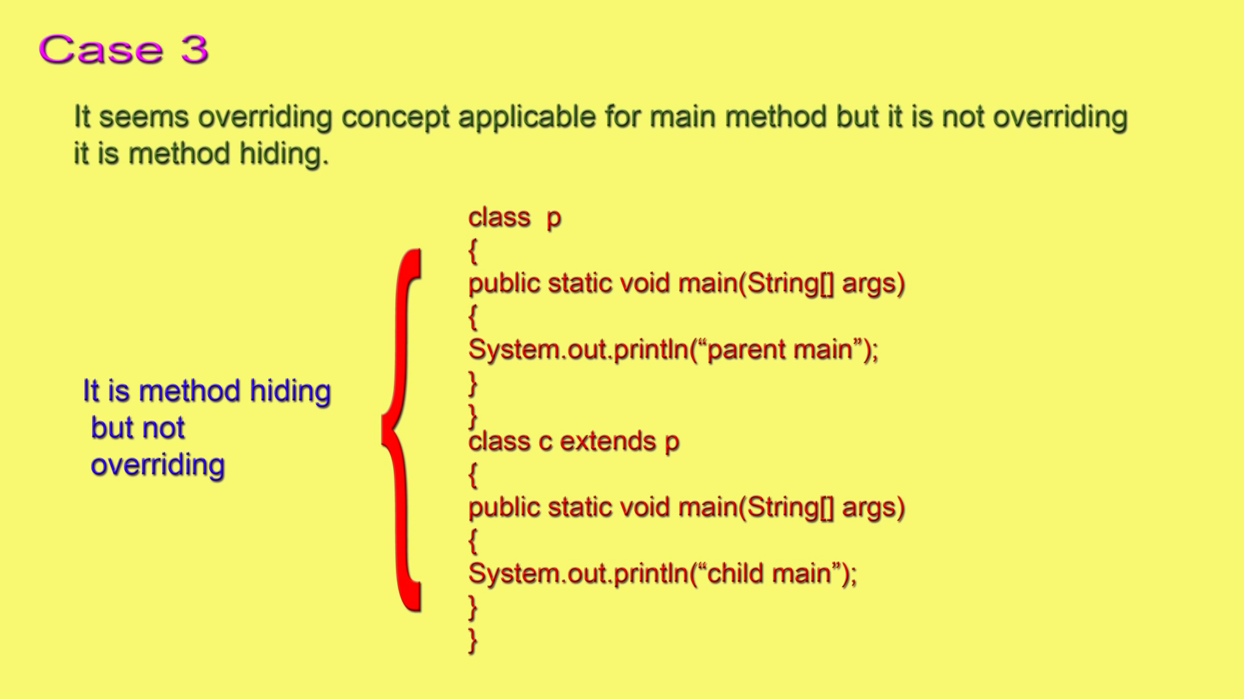

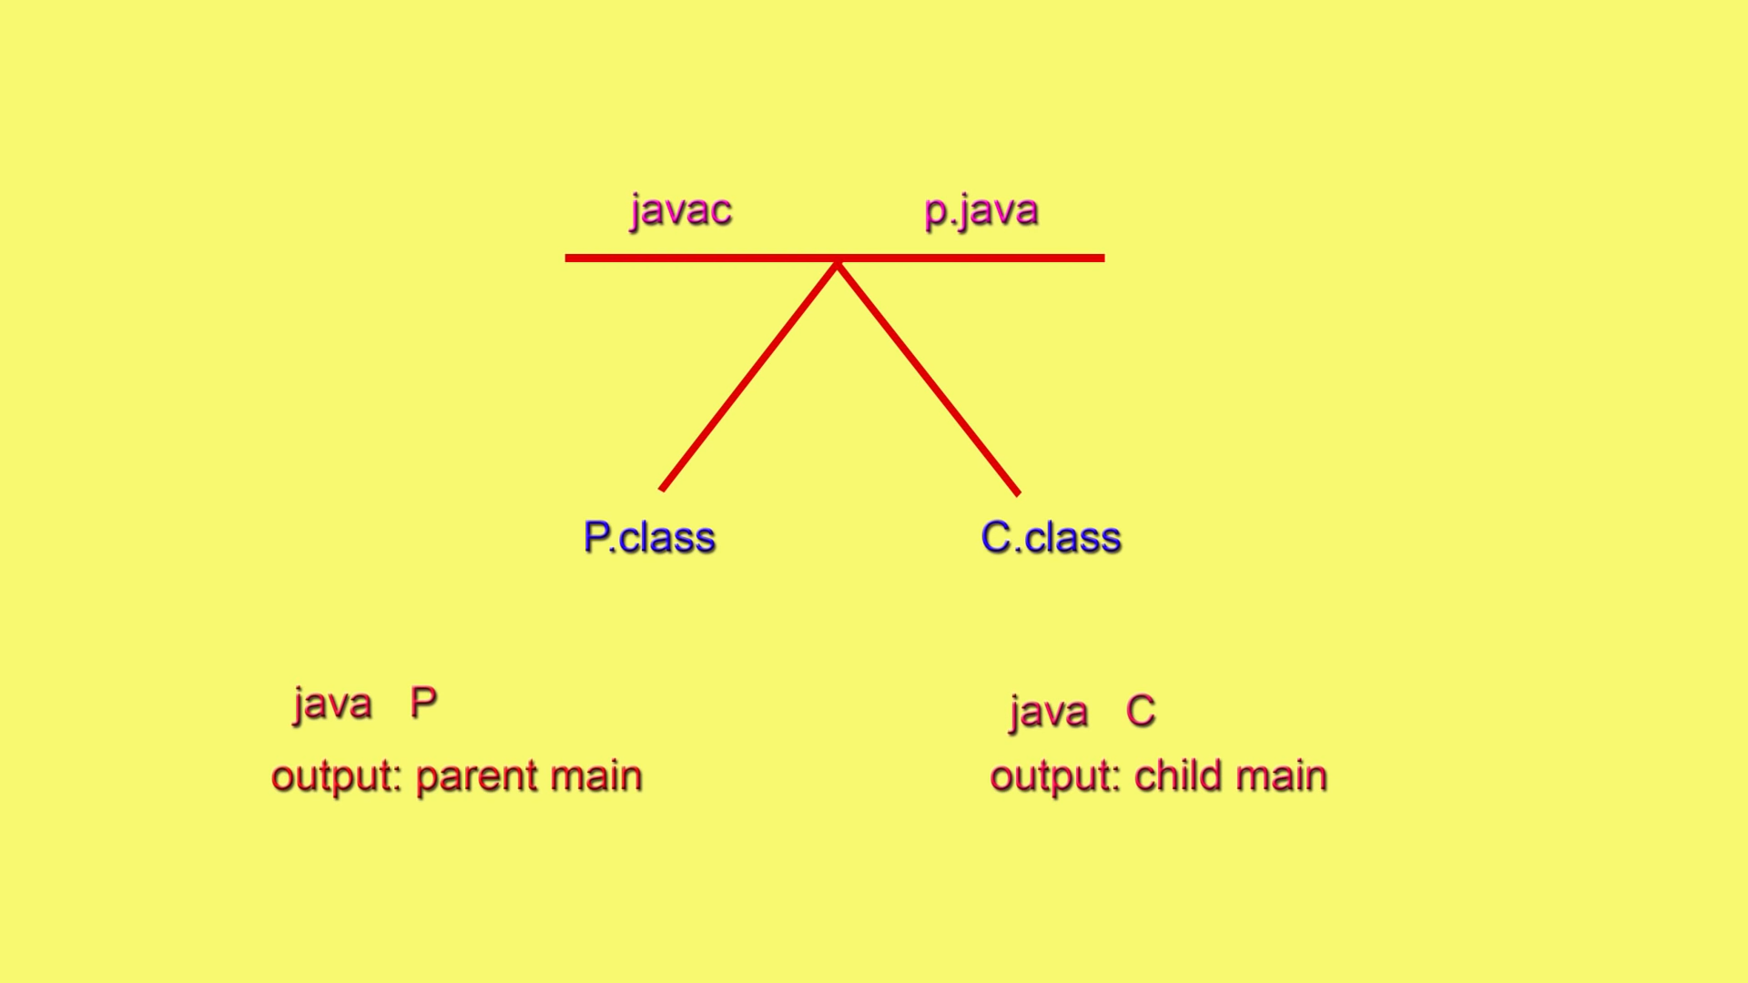

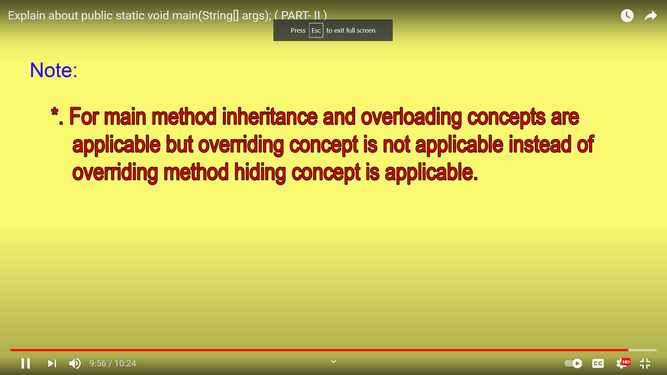

1.7v Enhancements for main method:

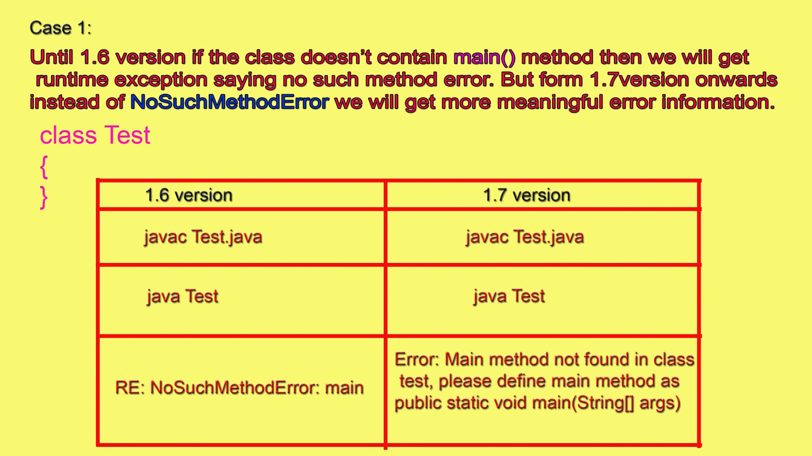

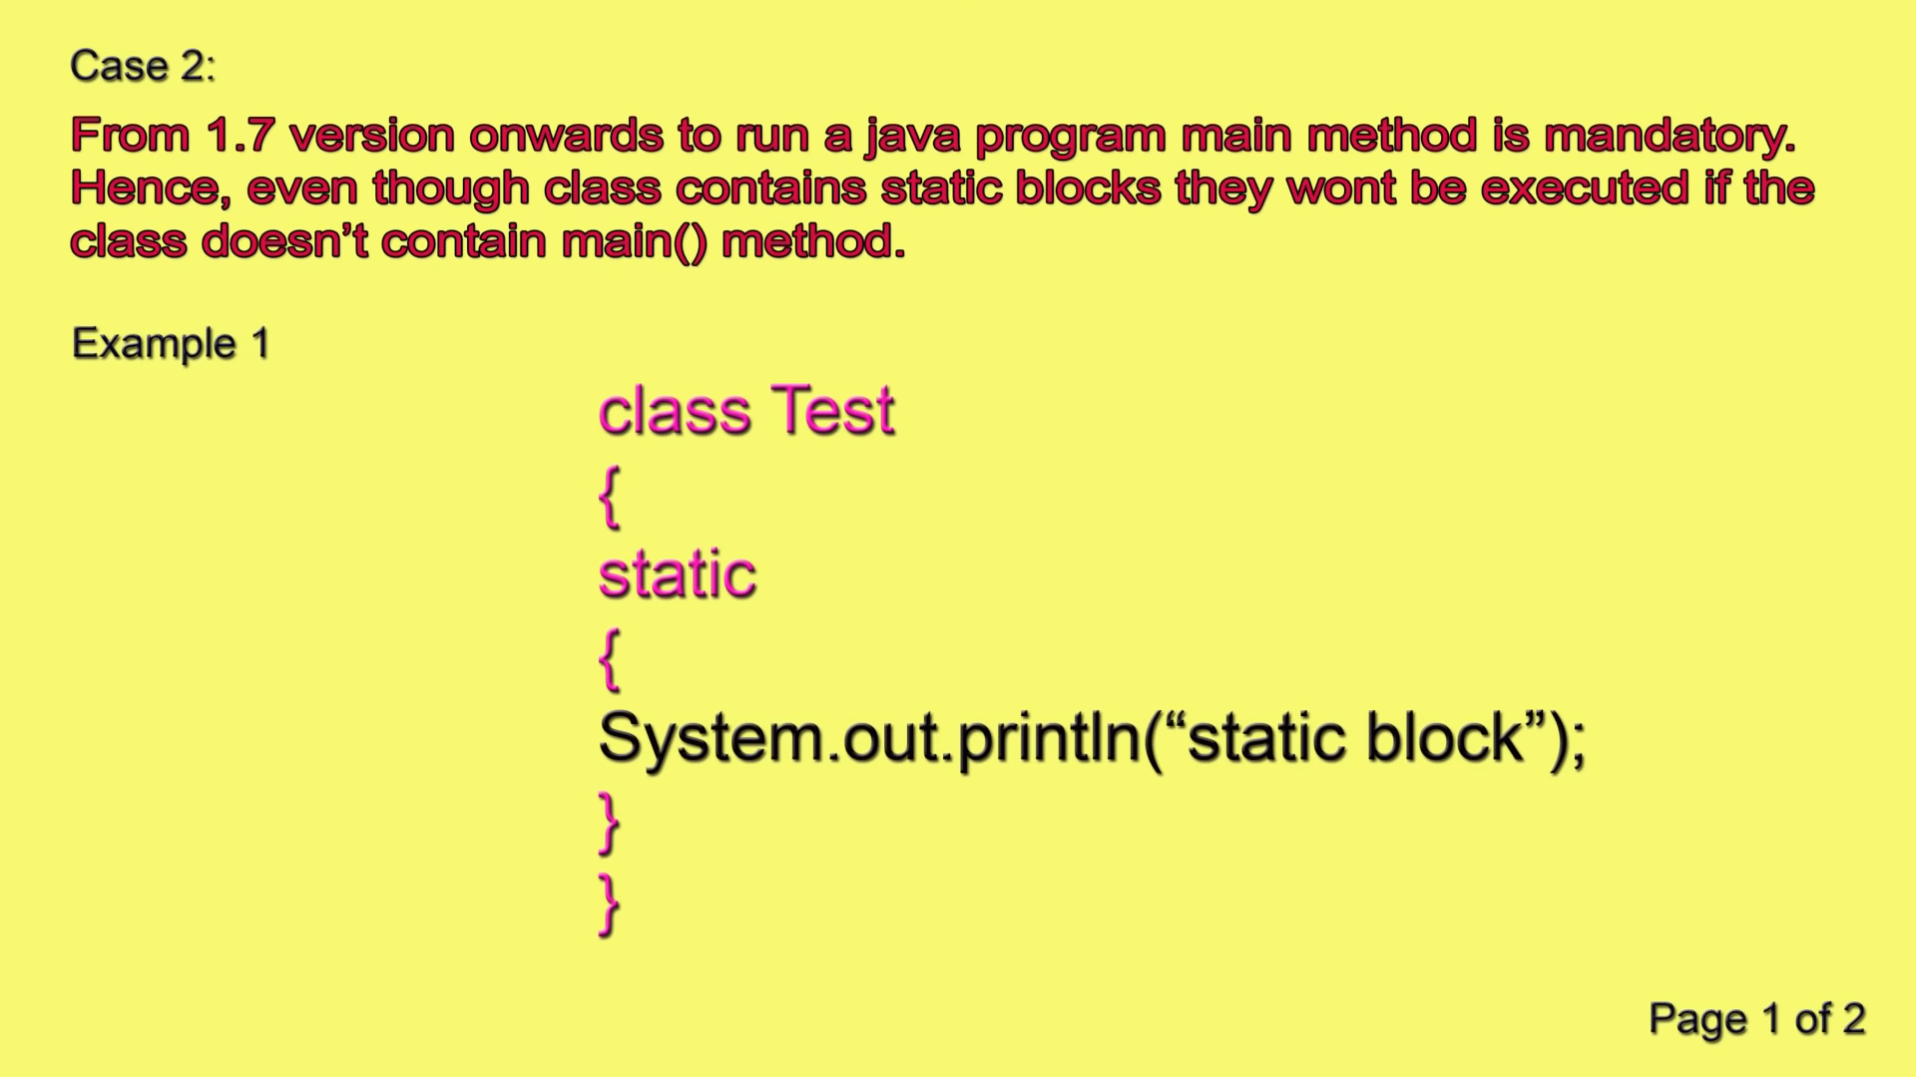

Initially, the static blocks were getting executed and then the error was thrown if main method not present.

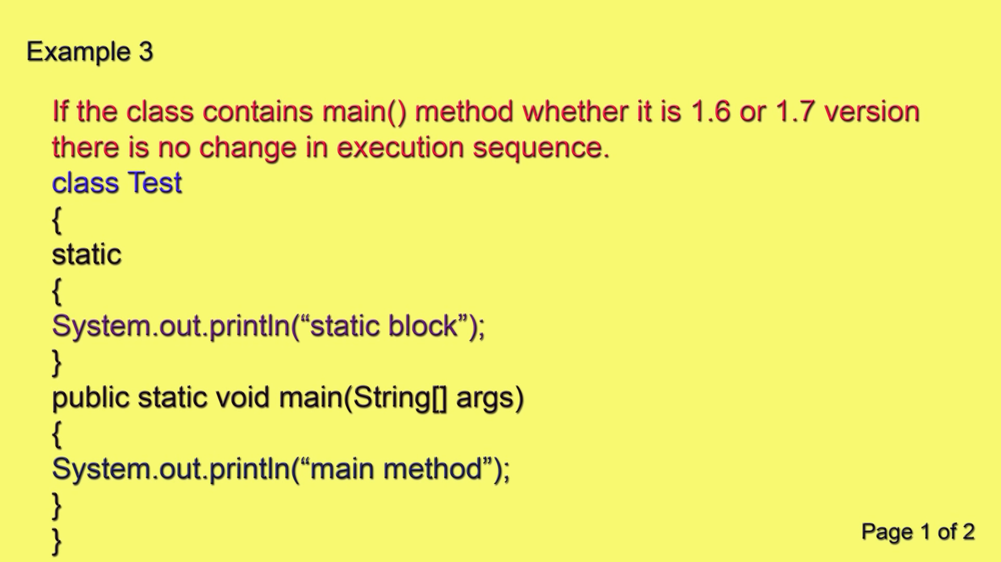

So, first static block will be executed and then main method but if main method is not present in 1.7, then it will throw error at start only without executing static block. So, JVM first checks for main method and then starts executing static blocks (if present) and then main.

Talk about sysout:

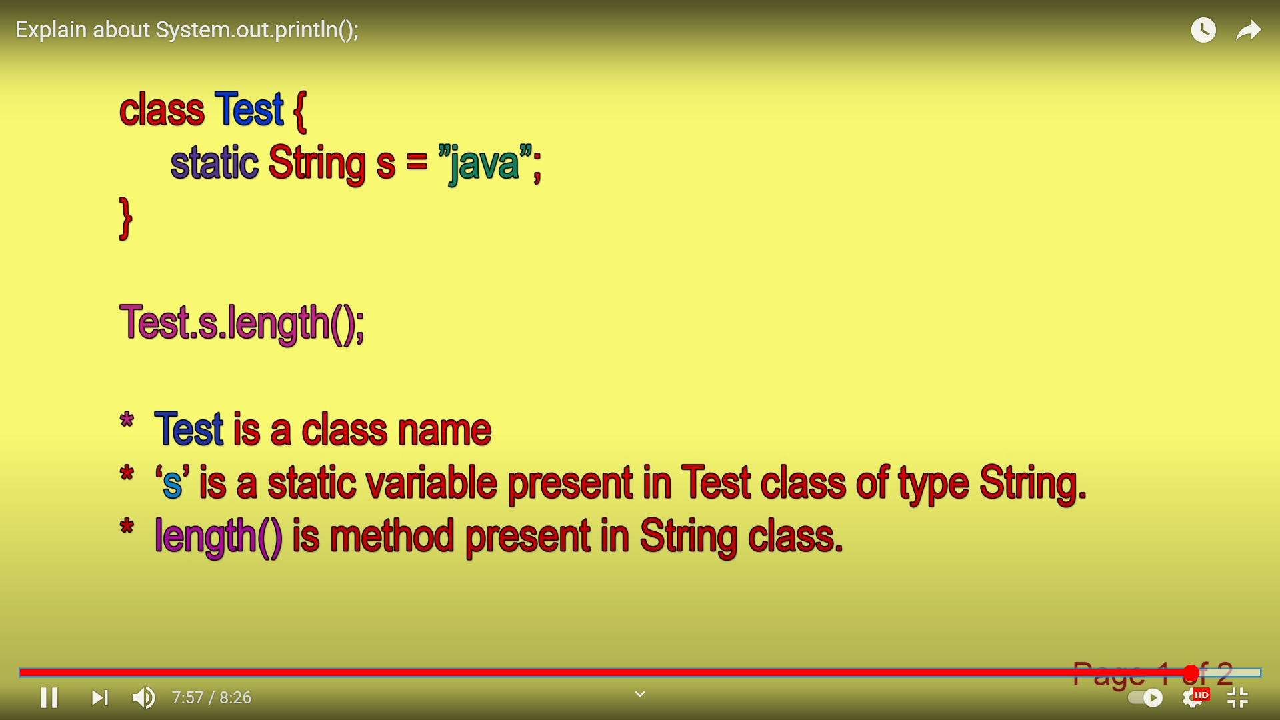

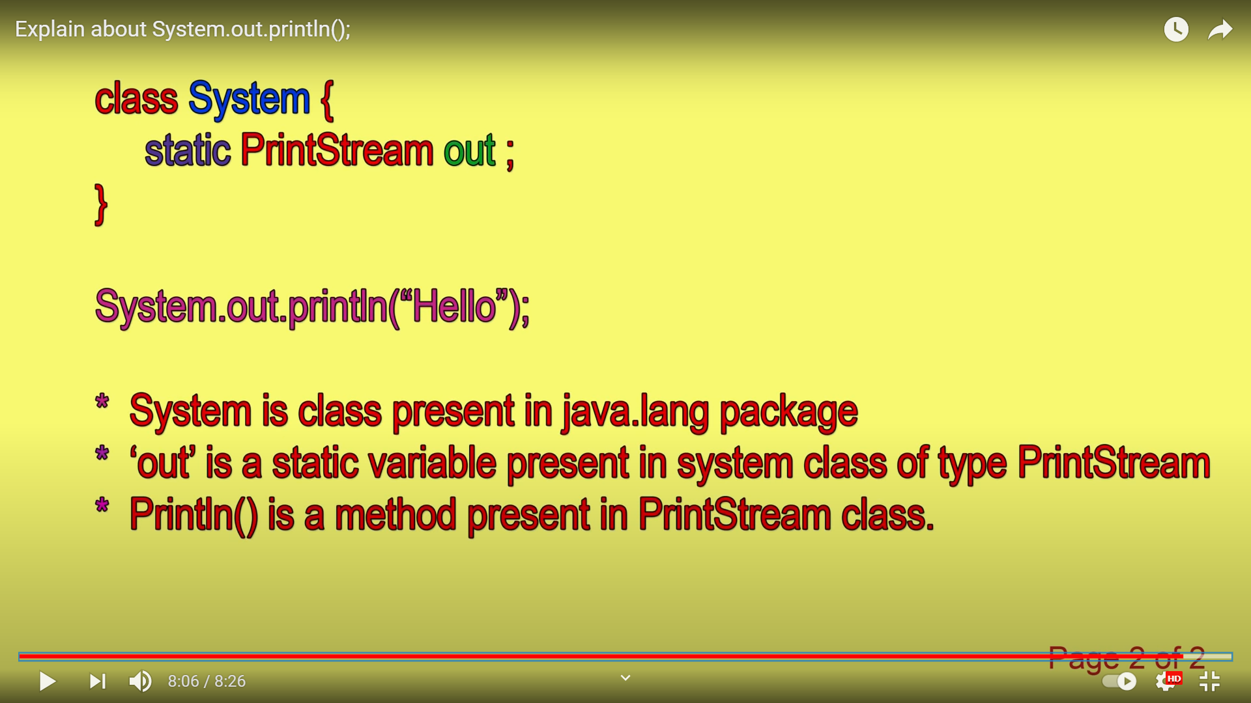

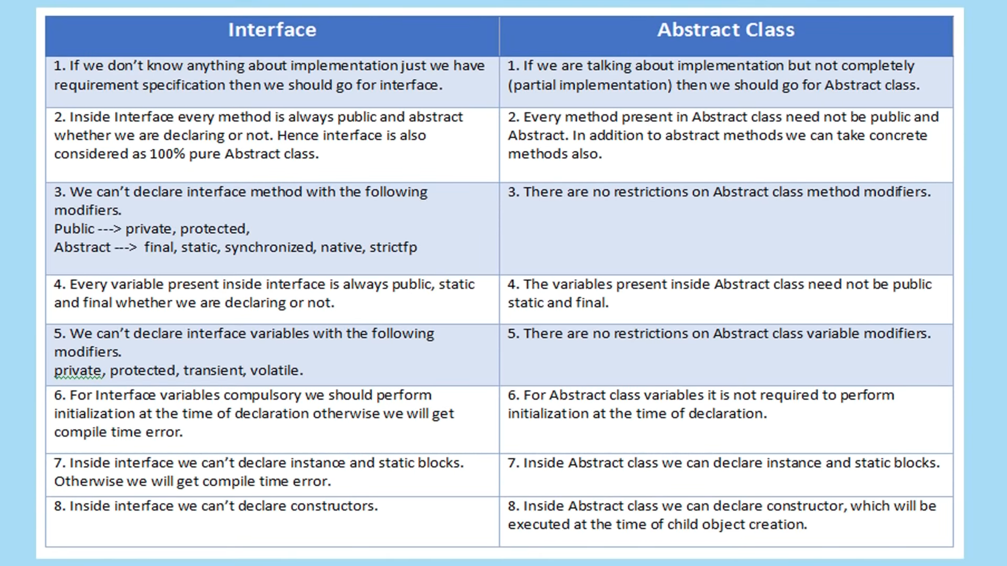

MAVEN (Project Management Framework) and SPRING BOOT:

Spring Boot Applications can be prepared using 3 things 🡪 Maven, Gradle and Yml

PRE-REQUISITE --- > Spring – Core, AOP, JDBC, ORM, **WEB MVC (imp)**

IDEs – STS, Eclipse IDE, IntellJ

Server- Spring Boot tool internally has Integrated/Embedded servers in it like Tomcat.

Spring Boot Requires some Project Management tool or build tools which is Maven

MAVEN – it is a German word which means Accumulator of Knowledge.

Apache Software foundation has undertaken Maven now.

Maven will do – It follows convention over configuration principle (Developers are not required to prepare build process their self. They do not need to mention each and every configuration details. Maven will take the responsibility to provide configuration details.)

Maven provides default and standard Project structure.

Downloading required Dependencies (jar Files), Maven takes the responsibility to download jars.

It Compiles Source Code. We can create Maven project without using Eclipse IDE as well. Eclipse IDE too is responsible to compile the code but Maven too has the capability.

Package projects as a .jar, .war or .ear file (Packaged project)

Start server automatically

Deploy project into the Server

Performs Unit Testing – It automatically performs Unit Testing. It is integration of Junit internally. So, whenever we create Maven project, we get Junit Internally.

Prepare Test Reports

If we do not want to maintain application on server at the end of application, Maven eill undeploy the application as well

Stops the Server automatically (internally)

POM -- > Project Object Model – Heart of Maven

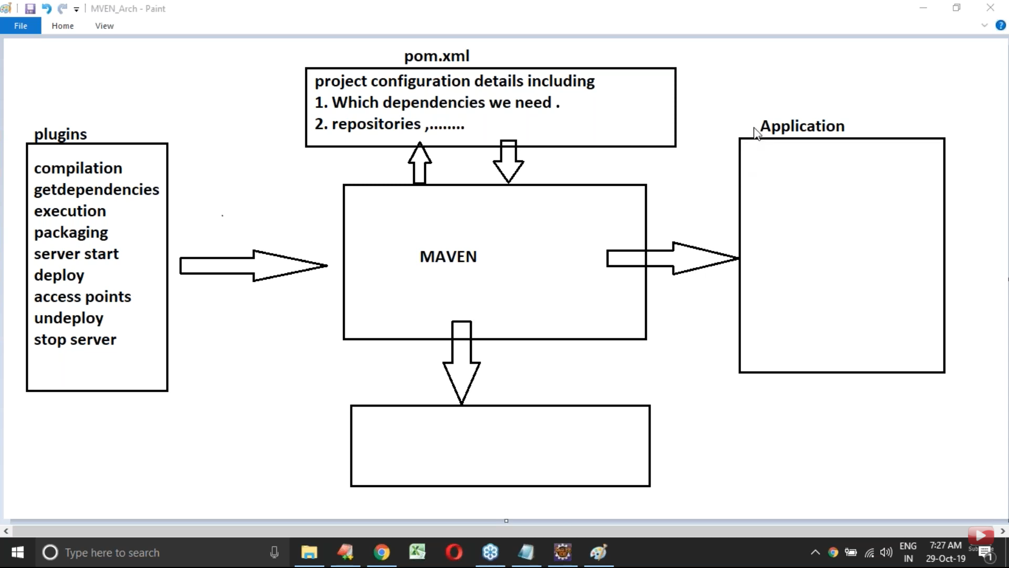

Maven is having number of plugins. Central one is Maven software. These plugins are given as input to the Maven software and Maven then interacts with the POM from where it will get the configuration details. Maven will download the require details from the internet from repositories and provide it to the application.

POM.xml file

Stands for Project Object model

It is fundamental unit and Heart in Maven

It is an xml file. It contains description and meta data of project and configuration details used to build a Maven project.

POM contains default values for Projects like build directories, such as src, target, main.. src/main/java , src/test/java.

When we execute Maven project, automatically Maven will search for the required configuration details in pom.xml file.

In Maven application, POM.xml is able to provide following configurations:

1. Project Description

2. Repository

3. Dependency Management

4. Project Inheritance

5. Build Configurations

6. Build Profile

1. Project Description:

It is the very first configuration in Maven. It includes various descriptions like Project Name, version number, packaged type. These project descriptions are present inside tags

<project> -- > This is the root type.

<modelNumber> --- > Describes which version of Maven we are using, < modelNumber > will take 4.0.0 as value to support for Maven2.0/3.0 versions.

<groupId> -- > uniquely identifies your project across all projects. It will take unique. A group ID should follow Java's package name rules. It will take Id of the project or the base package name.

<artifactId> -- > is the name of the jar without version. If you created it, then you can choose whatever name you want with lowercase letters and no strange symbols. A jar will be created using combination of groupId and artifactId only

<version> -- this will take the project version

2._ Repositories: It is a location or website, which provides Maven project required dependencies. When we execute Maven projects, Maven will search for all the dependencies in three (3) repositories

LOCAL REPOSOTORY – Location in our computer. It is created by Maven when we execute Maven command the very first time (.m2 repository).

CENTRAL REPOSITORY – it is default repository by Maven. It is located at

”http://repo1/maven.org/maven”

It is possible to use some other repositories (sites) also but we need to provide it’s configuration in pom.xml file. If dependencies are not available at local then maven will search for them at Central repository and if it is available then they are downloaded at local.

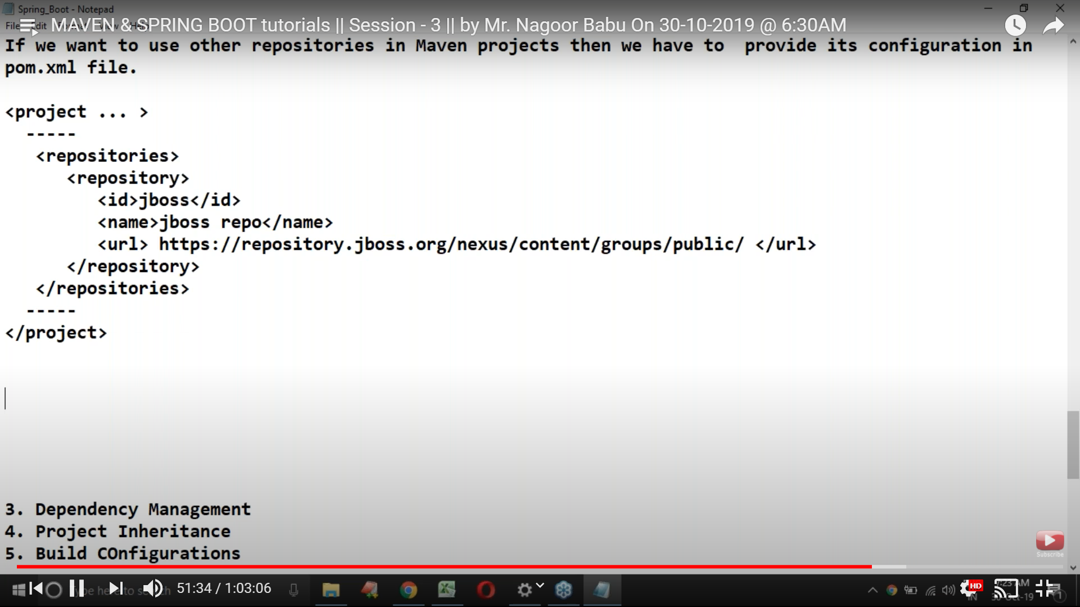

REMOTE REPOSITORY – It is a location in our company and it will be managed by the same organization to provide previous application support.

To configure remote repositories in Maven project, we have to use the following configuration details in pom.xml file as given above.

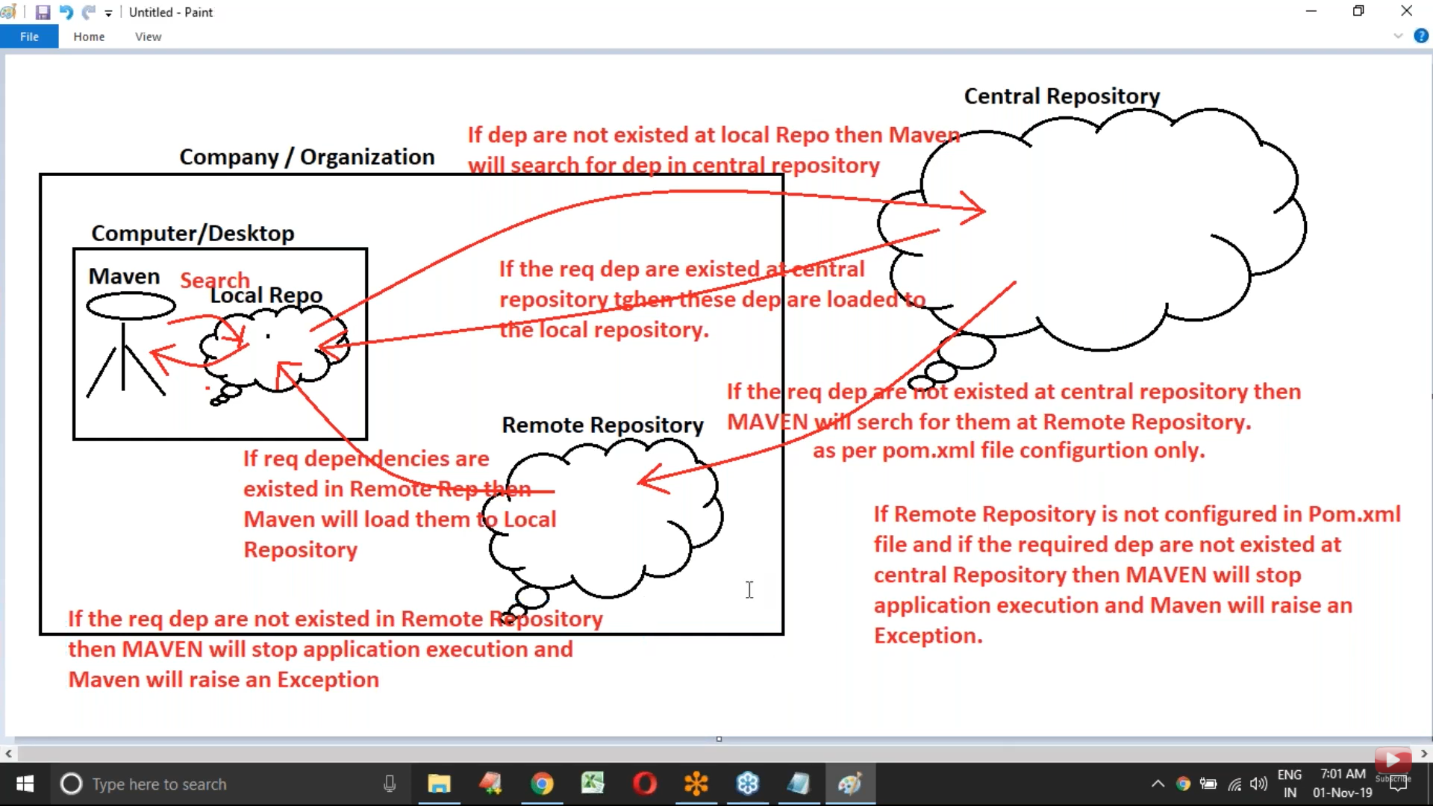3. Dependency Management – In Maven terminology, dependency is nothing but jar file or libraries which are required to perform configuration, debugging, test and execution of project.

So, we do not need to explicitly download the dependency. Maven will do it for us.

How Maven downloads the jars:

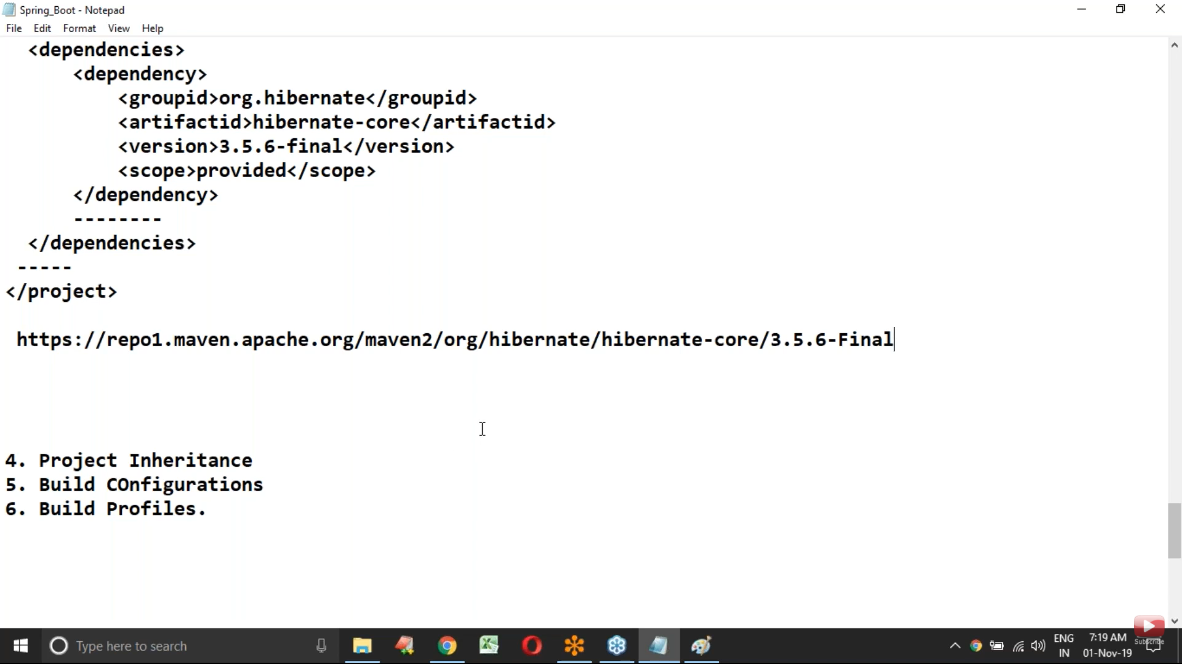

It will prepare and use the above URL -- > Central repo URL + groupId + artifactId + version number.

<scope> -- > In the project, some dependencies are required at all phases of the project life cycle while some are required at only few phases. This will provide lifetime to the dependencies in our project. Various values available for the dependency scope:

1. Compile – It is a default score. Will make the dependencies available to all the lifecycle phases of the project.
2. Provided -- Will make the dependencies available to compile and test phase. It will not provide libraries at Runtime. At runtime, maybe the containers (In Web apps) will provide the required API support to the applications. For example, at compile and test time, the servlet API is needs but at runtime, the application server will provide the Servlet API.
3. Runtime – This indicates that dependency is not required at compilation and is required only at Runtime. This is used to make dependencies available only at runtime.
4. Test
5. System
6. Import

4. Project Inheritance: